SG-24 Series

Screenless Granulators

Date: June, 2010

Version: V4.0 (English)

Contents

1. General Description ...................................................................................9
1.1 Feature ...............................................................................................10
1.2 Technical Specifications .....................................................................11
1.2.1 Technical Specifications ...........................................................11
1.2.2 Dimensions...............................................................................12
1.3 Safety Regulations..............................................................................13
1.3.1 Safety Signs and Labels ...........................................................13
1.3.2 Transportation and Storage of the Machine .............................15

2. Structural Features and Working Principle............................................17
2.1 General Description ............................................................................17
2.1.1 Working Principle......................................................................17
2.2 Safety system .....................................................................................18
2.2.1 Emergency Stop Switch ...........................................................18
2.2.2 Safety System ..........................................................................19
2.2.3 Lock..........................................................................................19
2.3 Assembly Drawing ..............................................................................20
2.3.1 Assembly Drawing (SG-2417) ..................................................20
2.3.2 Parts List (SG-2417).................................................................21
2.3.3 Assembly Drawing (SG-2427(H)) .............................................23
2.3.4 Parts List (SG-2427(H)) ............................................................24
2.3.5 Assembly Drawing (SG-2436(H)) .............................................28
2.3.6 Parts List (SG-2436(H)) ............................................................29
2.3.7 Assembly Drawing (SG-2446) ..................................................33
2.3.8 Parts List (SG-2446).................................................................34
2.3.9 Cutting Chamber ......................................................................36
2.3.10 Cutting Chamber Parts List......................................................36
2.3.11 Blade Rest ...............................................................................37
2.3.12 Transmission Parts ..................................................................38
2.3.13 Transmission Parts List ...........................................................38
2.3.14 Feed Box, Sound Insulation Box and Check Plate ..................39
2.3.15 Feed Box, Sound Insulation Box and Check Plate Parts List ..39

2.3.16 Storage Box.............................................................................39
2.3.17 Storage Box Parts List .............................................................39
2.3.18 Main Body................................................................................40
2.3.19 Main Body Parts List................................................................40
2.4 Electrical Diagram...............................................................................41
2.4.1 Main Circuit (400V)...................................................................41
2.4.2 Control Circuit Diagram (400V) ................................................42
2.4.3 Components Layout (400V)......................................................43
2.4.4 Electrical Components List (400V) ...........................................44
2.4.5 Main Electrical Circuit (230V) ...................................................47
2.4.6 Control Circuit Diagram (230V) ................................................48
2.4.7 Components Layout (230V)......................................................49
2.4.8 Electrical Components List (230V) ...........................................50
2.5 Electrical Components Description .....................................................53
2.6 Optional Accessories ..........................................................................54
2.6.1 30 seconds Instant Recycling System ......................................54
2.6.2 Manual Collective Storage Box ................................................54
2.6.3 Full Material Alarming Device ...................................................55
2.6.4 Proportional Valve ....................................................................55

3. Installation and Debugging .....................................................................56
3.1 Installation Notice:...............................................................................57
3.2 Installation Place.................................................................................58
3.3 Installation of Bearing and Blade Rest ................................................58
3.4 Installation of Belt Pulley and Motor....................................................59
3.5 Installation of Rotating Blade and Fixed Blade ...................................61
3.6 Installation of Feed Box, Feed Port and Storage Box .........................63

4. Operation Guide .......................................................................................65
4.1 Startup Pretest ....................................................................................65
4.1.1 Before the First Startup ............................................................65
4.1.2 After First Startup for 2 Hours...................................................65
4.1.3 After First Startup for 20~30 Hours...........................................65
4.2 Circuit Connection...............................................................................66
4.3 Open the Feed Box and Storage Box .................................................66
4.3.1 Open the Feed Box ..................................................................66

4.3.2 Open the Storage Box ..............................................................67
4.4 Shut the Feed Box and Storage Box...................................................67
4.4.1 Close the Feed Box ..................................................................67
4.4.2 Shut the Storage Box ...............................................................68
4.5 Start and Stop the Granulator .............................................................68
4.6 Motor Reversed Protective Function...................................................69

5. Trouble Shooting......................................................................................71
5.1 Granulator Doesn't Run ......................................................................71
5.2 Stop Due to Other Reasons ................................................................71

6. Maintenance and Repair ..........................................................................72
6.1 Repair .................................................................................................72
6.1.1 Replace the Blades ..................................................................72
6.2 Transmission ......................................................................................74
6.2.1 Daily Maintenance of Synchronous Belts .................................74
6.2.2 Adjustments of Synchronous Belts ...........................................75
6.3 Check and Maintenance of Gear Motor ..............................................75
6.4 Maintenance .......................................................................................76
6.4.1 Daily Check ..............................................................................76
6.4.2 Weekly Check ..........................................................................77
6.4.3 Monthly Check..........................................................................77
6.5 Cleaning..............................................................................................78
6.6 Maintenance Schedule .......................................................................79
6.6.1 About the Machine....................................................................79
6.6.2 Check After Installation.............................................................79
6.6.3 Daily Check ..............................................................................80
6.6.4 Weekly Check ..........................................................................81
6.6.5 Monthly Check..........................................................................82
6.6.6 Check Half-yearly or After 1000 Hours Running Check............83

Table index

Table 1-1：Technical Specifications .................................................................11
Table 2-1：Parts List (SG-2417) .......................................................................21
Table 2-2：Parts List (SG-2427) .......................................................................24

Table 2-3：Parts List (SG-2424H).....................................................................26
Table 2-4：Parts List (SG-2436) .......................................................................29
Table 2-5：Parts List (SG-2436H).....................................................................31
Table 2-6：Parts List (SG-2446) .......................................................................34
Table 2-7：Cutting Chamber Parts List.............................................................36
Table 2-8：Blade Rest Parts List ......................................................................37
Table 2-9：Transmission Parts List...................................................................38
Table 2-10：Feed Box, Sound Insulation Box and Check Plate Parts List........39
Table 2-11：Storage Box Parts List ..................................................................39
Table 2-12：Main Body Parts List .....................................................................40
Table 2-13：Electrical Components List of SG-2417/2427 (400V) ...................44
Table 2-14：Electrical Components List of SG-2427H/2436 (400V) .................45
Table 2-15：Electrical Components List of SG-2436H/2446 (400V) .................46
Table 2-16：Electrical Components List of SG-2417/2427 (230V) ...................50
Table 2-17：Electrical Components List of SG-2427H/2436 (230V) .................51
Table 2-18：Electrical Components List of SG-2436H/2446 (230V) .................52

Picture index

Picture 1-1：Dimensions ...................................................................................12
Picture 2-1：Working Principle..........................................................................17
Picture 2-2：Safety System ..............................................................................18
Picture 2-3：Emergency Stop Switch................................................................18
Picture 2-4：Safety System ..............................................................................19
Picture 2-5：Assembly Drawing (SG-2417) ......................................................20
Picture 2-6：Assembly Drawing (SG-2427(H)) .................................................23
Picture 2-7：Assembly Drawing (SG-2436(H)) .................................................28
Picture 2-8：Assembly Drawing (SG-2446) ......................................................33
Picture 2-9：Cutting Chamber ..........................................................................36
Picture 2-10：Blade Rest ..................................................................................37
Picture 2-11：Transmission Parts .....................................................................38
Picture 2-12：Feed Box, Sound Insulation Box and Check Plate .....................39
Picture 2-13：Storage Box ................................................................................39
Picture 2-14：Main Body...................................................................................40

Picture 2-15：Main Circuit (400V) .....................................................................41
Picture 2-16：Control Circuit Diagram (400V)...................................................42
Picture 2-17：Components Layout (400V)........................................................43
Picture 2-18：Main Electrical Circuit (230V) .....................................................47
Picture 2-19：Control Circuit Diagram (230V)...................................................48
Picture 2-20：Components Layout (230V)........................................................49
Picture 2-21：Electrical Components Description .............................................53
Picture 2-22：30 seconds Instant Recycling System ........................................54
Picture 2-23：Manual Collective Storage Box...................................................54
Picture 2-24：Alarm ..........................................................................................55
Picture 2-25：Material Level Motor ...................................................................55
Picture 2-26：Control Box, Valve body .............................................................55
Picture 3-1：Installation Space .........................................................................57
Picture 3-2：Installation Place ..........................................................................58
Picture 3-3：Installation of Bearing and Blade Rest 1.......................................58
Picture 3-4：Installation of Bearing and Blade Rest 2.......................................58
Picture 3-5：Installation of Bearing and Blade Rest 1 3....................................59
Picture 3-6：Installation of Belt Pulley and Motor 1 ..........................................59
Picture 3-7：Installation of Belt Pulley and Motor 2 ..........................................60
Picture 3-8：Installation of Belt Pulley and Motor 3 ..........................................60
Picture 3-9：Installation of Belt Pulley and Motor 4 ..........................................60
Picture 3-10：Installation of Belt Pulley and Motor 5.........................................60
Picture 3-11：Installation of Belt Pulley and Motor 6.........................................61
Picture 3-12：Installation of Belt Pulley and Motor 7.........................................61
Picture 3-13：Installation of Belt Pulley and Motor 8.........................................61
Picture 3-7：Installation of Rotating Blade and Fixed Blade 1 ..........................62
Picture 3-8：Installation of Rotating Blade and Fixed Blade 2 ..........................62
Picture 3-9：Installation of Rotating Blade and Fixed Blade 3 ..........................62
Picture 3-17：Installation of Feed Box, Feed Port and Storage Box 1 ..............63
Picture 3-18：Installation of Feed Box, Feed Port and Storage Box 2 ..............63
Picture 3-19：Installation of Feed Box, Feed Port and Storage Box 3 ..............63
Picture 3-20：Installation of Feed Box, Feed Port and Storage Box 4 ..............64
Picture 3-21：Installation of Feed Box, Feed Port and Storage Box 5 ..............64
Picture 4-1：Open the Feed Box ......................................................................67

Picture 4-2：Air Spring......................................................................................67
Picture 4-3：Main Power Switch .......................................................................68
Picture 4-4：Button ...........................................................................................69
Picture 4-5：Motor Reversed Protective Function ............................................70
Picture 6-1：Replace the Blades ......................................................................72
Picture 6-2：Remove the Fixed Blades.............................................................73
Picture 6-3：Remove the Rotating Blades ........................................................73
Picture 6-4：Transmission ................................................................................74
Picture 6-5：Adjustments of synchronous Belts 1.............................................75
Picture 6-6：Adjustments of synchronous Belts 2.............................................75
Picture 6-7：Star Screw ....................................................................................77
Picture 6-8：Cleaning .......................................................................................78

1. General Description

Please read this manual carefully before using this machine in order to operate correctly against any damage caused due to improper operation.

Note!
Always take great care when the knives are within reach, they are very sharp and can cause personal injury.

Forbidden to process flammable or toxic material!

SG - 14 series granulators operate in super low speed to cut materials into well - proportioned granules. There are least dusts produced in the cutting process. Multiple security devices ensure high safety grade; automatic reverse running function ensures continuous operation. This series of screenless granulators are suitable for granulating hard and thick materials.

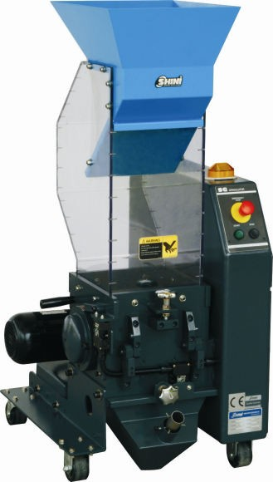

Model: SG-2427

1.1 Feature

1) SG - 24 series German - made gear motor features steady performance, long service life and high torque.
2) SG - 24 series teeth cutters and cutting blades are integrally fitted in one cutting chamber. Staggered blades make the initial cutting and teeth cutters reduce the materials into desired size. Regrinds could be used with virgin materials
3) Screenless design, well - proportioned size of regrinds and least amount of dusts. Regrinds could be used with virgin materials.
4) SG - 24 series unique synchronous transmission belt ensure smooth running of the machine and low noise level.
5) When motor blockage occurs, the machine will alarm visibly and enable motor reverse running function. It resumes normal operation automatically after the trouble is clear.
6) "Euro" style appearance, compact in size and easy to access for cleaning and maintenance.
7) Transparent PC feeding hopper.
8) Upon request, it can be built to comply with worldwide electrical safety standards ( For example : CE, UL, CSA, JIS etc. ).

All service work should be carried out by a person with technical training or corresponding professional experience. The manual contains instructions for both handling and servicing. Chapter 6, which contains service instructions intended for service engineers. Other chapters contain instructions for the daily operator.

Any modifications of the machine must be approved by SHINI in order to avoid personal injury and damage to machine. We shall not be liable for any damage caused by unauthorized change of the machine.

Our company provides excellent after-sales service. Should you have any problem during using the machine, please contact the company or the local vendor.

Headquarter and Taipei factory：
Tel: 0800-000-860

1.2 Technical Specifications

1.2.1 Technical Specifications

Table 1-1：Technical Specifications

Model | SG-2417 | SG-2427(H) | SG-2436(H) | SG-2446
Motor Power (kW, 50/60Hz) | 0.75 | 0.75(1.5) | 1.5(2.2) | 2.2
Rotating Speed (r.p.m, 50/60Hz) | 26 | 26 | 26(27) | 27
Material of Teeth Cutters | SKD-11 | SKD-11 | SKD-11 | SKD-11
Number of Cutting Blades | 1 | 2 | 3 | 4
Number of Teeth Cutters | 2 | 3 | 4 | 5
Number of Large Teeth Cutlers | / | / | / | /
Number of Small Teeth Cutlers | / | / | / | /
Cutting Chamber (mm) | 240×175 | 240×270 | 240×365 | 240×460
Max. Throughput Capacity  (kg/hr, 50/60Hz) | 3.5 | 6(6.5) | 8.5(9) | 11
Noise Level dB(A) | 65~73 | 65~73 | 67~75 | 75~83
30-Sec. Instant Recycling
Regrind Conveyor (BC Type)
Dust Separator
Level Detector | -
Proportional Valve
Manual Storage Bin
Dimensions
H (mm) | 1335 | 1335 | 1335 | 1335
H1 (mm) | 835 | 835 | 835 | 835
W (mm) | 480 | 576 | 672 | 768
W1 (mm) | 290 | 386 | 482 | 578
D (mm) | 700 | 700 | 700 | 700
D1 (mm) | 449 | 449 | 449 | 449
Weight (kg) | 252 | 279(303) | 331(369) | 399
Note: 1) "○" optional.
2) For stainless steel made feed port and manual storage bin, plus "R" at model behind.
3) Max. Capacity of the machine is subject to the size and composition of the material.
4) Noise level will vary with different materials.
5) SKD-11 is material code number of Japanese JIS standard.
6) V-type balde is standard, dilated V-type blade is optional
7) For avoiding plastic to adhibit the blade, all materials should be crushed at normal temperature.
8) Power supply: 3Φ, 230 / 400 / 460 / 575V, 50 / 60Hz.

1.2.2 Dimensions

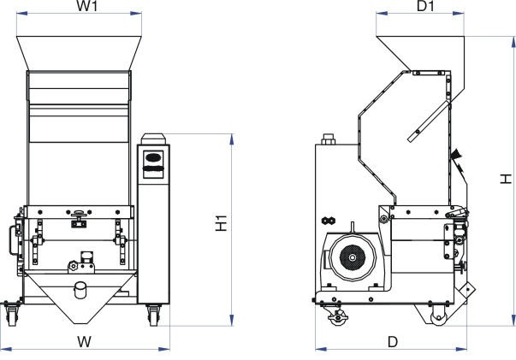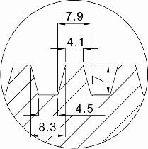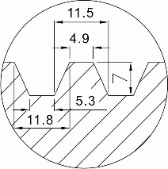

Option

Picture 1-1：Dimensions

1.3 Safety Regulations

Follow the instructions in this manual to avoid personal injury and damage to machine components.
The following safety measures shall be followed when operating the granulator.

1.3.1 Safety Signs and Labels

Electrical installation must only be done by a competent electrician!

Before the granulator is opened for servicing and maintenance, always disconnect the power with both the main switch and the control switch on
the granulator.

Never put any part of your body through the granulator openings, unless both the main switch and the control switch on the granulator are in
"OFF" position.

High voltage！danger！

This sign is attached on the control box and the wiring box.
Be careful with the rotating knives, they are very sharp and can cause personal injury!
The granulator should not be started before the feed box and storage box are properly closed.
Attention please!
Ear protection is used during granulating of plastic materials.

Make sure the power has been cut off before open the feed box.

SG-24 Granulators cannot deal with fibre added material.

Attention！

No need for regular inspection because all the electrical parts in the control unit are fixed tightly！
When operate the granulator, please notice the following signs

Hazard
High voltage !
May lead to casualty or other serious danger. Please cut off the power before repairing. Circuit diagram should only be changed by professionals.
Grounding is necessary.
Warning
Pinch risk when moving belt.
Take out or open protective cover is not allowed when it is running.
Warning
There is a pinch risk for this protective cover keep some distance away from that.
Warning
The cutter are very sharp, can cause injury take out or open protective cover is not allowed when it is running.
Keep some distance away from the cutters.
Notice
Read the instruction manual carefully before operating.
Before start, do the safety device test according to the instruction. It is not allowed to change the design of the machine unless it is approved from the manufacturer.

1.3.2 Transportation and Storage of the Machine

Transportation

1) SG-24 series of granulators are packed in plywood cases with wooden pallet at the bottom, suitable for quick positioning by fork lift.
2) After unpacked, castors equipped on the machine can be used for ease of movement.
3) Do not rotate the machine and avoid collision with other objects during transportation to prevent improper functioning.
4) The structure of the machine is well-balanced, although it should also be handled with care when lifting the machine for fear of falling down.
5) The machine and its attached parts can be kept at a temperature from -25℃ to +55℃ for long distance transportation and for a short distance, it can be transported with temperature under +70℃.
Storage
1) SG-24 series should be stored indoors with temperature kept from 5℃to 40℃
and humidity below 80%.
2) Disconnect all power supply and turn off main switch and exigency stop switch.
3) Keep the whole machine, especially the electrical components away from water to avoid potential troubles caused by the water.
4) Use plastic film to cover the machine tightly to prevent the machine from dust and rains.

Working environment
The machine should be operated:
1) Indoors in a dry environment with max. temperature +45℃ and humidity no more than 80%.

Do not use the machine:

1) If it is with a damaged cord.
2) On a wet floor or when it is exposed to rain to avoid electric shock.
3) If it has been dropped or damaged until it is checked or fixed by a qualified serviceman.

4) This equipment works normally in the environment with altitude over
3000m.
5) At least 1m surrounding space is requested when this equipment is running. Keep this equipment away from flammable sources at least two meters.
6) In the work area of vibration and strong magnetic force.

Rejected parts disposal
When the equipment has run out its life time and can not be used any more, unplug the power supply and dispose of it properly according to local code.

Fire hazard!
In case of fire, CO2 dry powder fire extinguisher should be applied.

Flammable materials or materials which are contaminated by flammable substances/liquid may not be processed in the granulator. Serious risk of
fire or explosion may cause personnel injury.

It is very important to tighten the screw as required torque.

When process item is longer than feed port, please cut long items into
half until the length is shorter before processing.

Please don’t put materials into the granulator if they are thinner than 2 mm and are soft and flexible, like rubber.

2. Structural Features and Working Principle

2.1 General Description

SG-24 series are belong to "by the press" granulator, which are designed for grinding different types of plastic waste. It is mainly equipped with the moulding machine to grind small quantity of material, so don't put large quantity of material for granulating. The granulator are controlled by main power switch, emergency stop button, start button, stop button and safety switches.

2.1.1 Working Principle

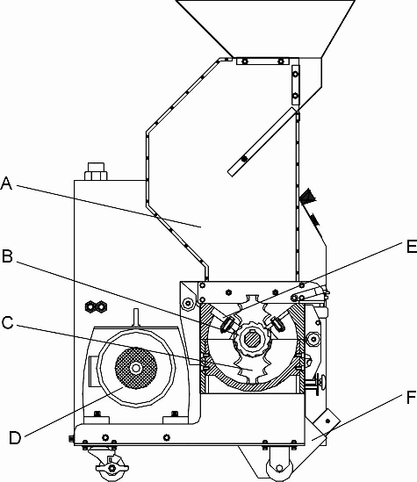

Parts name:

A. Feed box B. Teeth cutter C. Staggered blade D. Motor

E. Fixed blade F. Storage box

Picture 2-1：Working Principle
Materials fall into the teeth cutter chambers (B) from feed box (A) the block material is cutted by the staggered blades(C) and fixed knives (E), then the material is cutted into granule by (B) and (E). The granule directly fall into the storage box(F), it does not need the screen. The cutting chamber is easy to

open for cleaning and maintenance. After this, the granulate is ready for re-use in the production machine, or to be transported to a container for later use.
2.2 Safety System

To avoid accidental bodily injury during granulator running, a set of safety system has been designed.
High-speed rotating cutter is located in the granulator and subject to accident. So safety system has been set up to protect bodily safety.
In any cases, the safety system cannot be changed at random. Otherwise the machine will be under dangerous condition and subject to accident happening. The maintenance and preservation of safety system shall be done by professional staff. In case the safety system of granulator is changed, our company will not perform our commitment. The replacement of all spare parts will be done by SHINI Company.
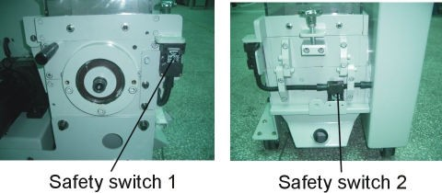

Picture 2-2：Safety System
2.2.1 Emergency Stop Switch

There is one red button on the control panel. Upon pushing it, the machine will stop running. Turn the button in the arrow direction as shown on the button, the button will reset (counter-clockwise).
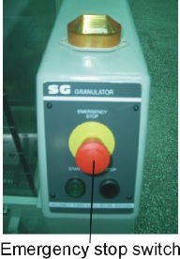

Picture 2-3：Emergency Stop Switch

2.2.2 Safety System

On the granulator is equipped the safety switch for circuit breaker. In case
either position of feed box or storage box is changed or the breaker is loosened, it will cut off the power supply. There are two safety switches on the granulator: one is located between the feed box and the cutting chamber while the other one is on the cutting chamber and linked with the storage box.

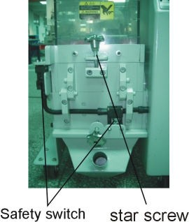

2.2.3 Lock
Picture 2-4：Safety System

The lock of the machine is a long hexagonal screw, which can extend the time of door opening to avoid any injury. When opening the door, this hexagonal screw shall be loosened. Loosening the door-lock needs a period of time avoiding personnel injury.

1) Check if the feed box has been locked up.
2) Shut the feed box and lock the star screw tightly.
3) Check if the teeth cutter chamber has foreign materials (such as metal chip).

2.3 Assembly Drawing

2.3.1 Assembly Drawing (SG-2417)

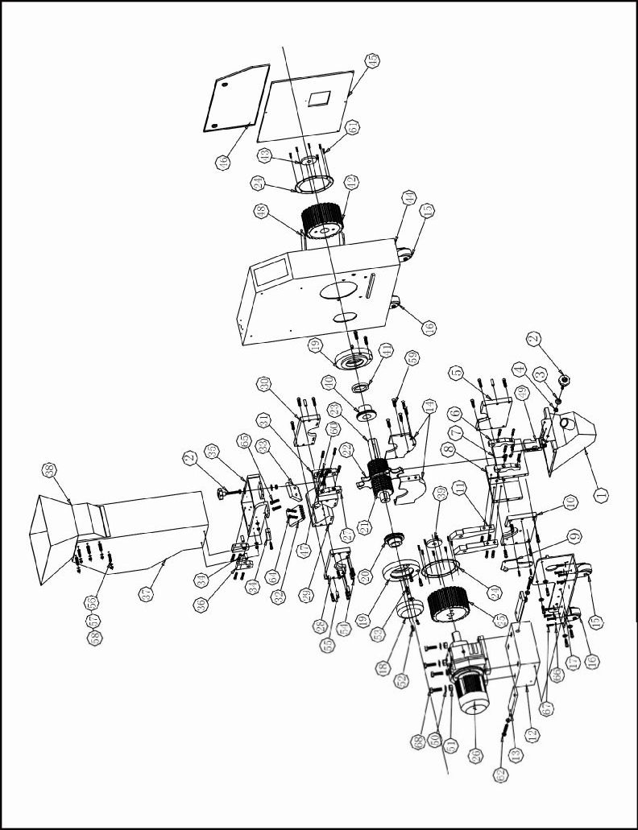

Note: Please refer to 2.3.2 material list about the parts code.

Picture 2-5：Assembly Drawing (SG-2417)

2.3.2 Parts List (SG-2417)

Table 2-1：Parts List (SG-2417)

No. | Name | Part No. | No. | Name | Part No.
1 | Storage box | BL51241710020 |  | Fix the font blade F1 (6×7)* | YW40240700000
2 | Star knob(M12)** | BH11127000010 | 33 | Fix the back blade B (4×5.3)* | YW40241300000
3 | Gasket ф12×24 | YW66123200100 |  | Fix the back blade B (5×5.3)* | YW40024000300
4 | Fastening screw M12 | YW64000300000 |  | Fix the back blade B (6×7)* | YW40240900000
5 | Right bottom bearing holder | BH10240000010 | 34 | Locating block (4) | BH10024000510
6 | Location block (1) | BH10024000310 | 35 | Bottom base of feed box | BH10241700210
7 | Front bottom housing | BH10241700110 | 36 | Locating block (5) | BH10024000510
8 | Back bottom housing | BH10241700010 | 37 | Feed box | YR90241700000
9 | Locating block (3) | BH10024000110 | 38 | Feed port | BL56241700020
10 | Left bottom bearing holder | BH10240000110 | 39 | Gasket 2 | BL51801200020
11 | Locating block (5) | BH10024000510 | 40 | Right bearing sleeve | YW30002400100
12 | Fixing block for gear motor | BH10244601210 | 41 | Stop ring | BH10002401110
13 | Position-adjusting plate | BH10002410010 | 42 | Synchronous pulley (1) | BW08244500010
14 | Interlayer | BH10002400810 | 43 | Gasket 1 | BL51802100020
15 | Fixed castor | YW03000300500 | 44 | Out housing | -
16 | Rotary castor | YW03000300200 | 45 | Top side plate | -
17 | Castor fixing plate | - | 46 | Top side plate | -
18 | Bearing cover | BL51002402420 | 47 | Locating block (2) | BH10024000210
19 | Left and right bearing block | BW30306000410 | 48 | Synchronal belt ** | YR00105800000
20 | Left bearing sleeve | YW30024000200 | 49 | Safety switch * | YE16147600100
21 | Teeth cutter (4×5.3)* | YW40241400000 | 50 | Flat washerФ16×32 | YW66164000000
 | Teeth cutter (5×5.3)* | YW40024000400 | 51 | Nuts M | YW64001600000
 | Teeth cutter (6×7)* | YW40241000000 | 52 | Inner hexagon screw | YW61053000100
22 | Staggered blade* | YW40245000000 | 53 | Inner hexagon screw | YW61124000000
23 | Shaft | BH10241701010 | 54 | Inner hexagon screw | YW61103500000
24 | Synchronous pulley gasket | YW69012700000 | 55 | Spring positioning pin | YW69123500000
25 | Synchronous pulley (2-1) | BW08243500010 | 56 | Inner hexagon lentil heated screw | YW61082000300
26 | Gear motor (0.75kW) | YM10578000000 | 57 | Flat washer | YW66081900000
27 | Locating block (1) | BH10024000310 | 58 | Loose-proof nut | YW64000800100
28 | Left top bearing holder | BH10240000310 | 59 | Countersunk head screw | YW61082000100
29 | Back top housing block | YW30241700000 | 60 | Inner hexagon screw | YW61106500000
30 | Right bearing holder on top housing | BH10240000210 | 61 | Countersunk head screw | YW62051000100
31 | Front top housing block | BW30241700110 | 62 | Outer hexagon screw | YW60125000100
32 | Fix the font blade F1(4×5.3)* | YW40241100000 | 63 | Flat washer | YW66123200100
 | Fix the font blade F1(5×5.3)* | YW40024000100 | 64 | Outer hexagon screw | YW60103500000

No. | Name | Part No. | No. | Name | Part No.
65 | Outer hexagon screw | YW60103000000 | 67 | Outer hexagon screw | YW60082000100
66 | Flat washer | YW66081600000 | 68 | Outer hexagon screw | YW60165000000
* means possible broken parts.
** means easy broken part. and spare backup is suggested.
Please confirm the version of manual before placing the purchase order to guarantee that the item number of the spare part is in accordance with the real object.

2.3.3 Assembly Drawing (SG-2427(H))

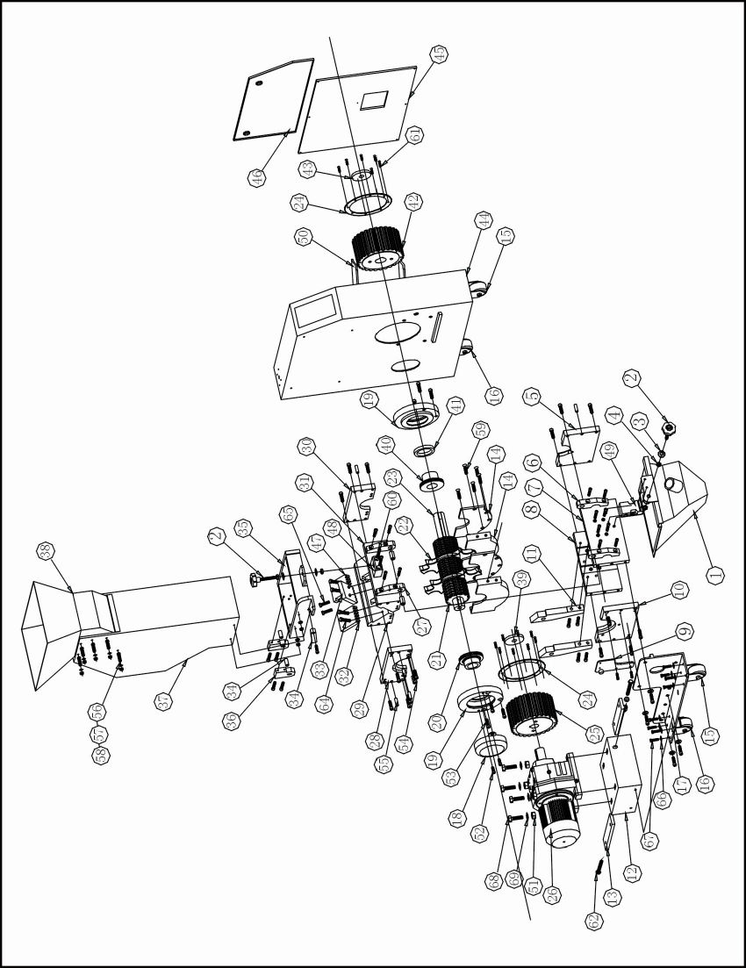

Note: Please refer to 2.3.4 material list about the parts code.

Picture 2-6：Assembly Drawing (SG-2427(H))

Table 2-2：Parts List (SG-2427)

No. | Name | Part No. | No. | Name | Part No.
1 | Storage box | BL51242710020 |  | Fix the font blade F1 (6×7)* | YW40240700000
2 | Star knob** | BH11127000010 | 33 | Fix the back blade B (4×5.3)* | YW40241300000
3 | Gasket ф12×24 | YW66123200100 |  | Fix the back blade B (5×5.3)* | YW40024000300
4 | Fastening screw M12 | YW64000300000 |  | Fix the back blade B (6×7)* | YW40240900000
5 | Right bottom bearing holder | BH10240000010 | 34 | Locating block (4) | BH10024000510
6 | Location block (1) | BH10024000110 | 35 | Bottom base of feed box | BH10242700210
7 | Front bottom housing | BH10242700610 | 36 | Locating block (5) | BH10024000610
8 | Back bottom housing | BH10242700410 | 37 | Feed box | YR90242700100
9 | Locating block (3) | BH10024000310 | 38 | Feed port | BL56242700020
10 | Left bottom bearing holder | BH10240000110 | 39 | Gasket 2 | BL51801200020
11 | Locating block (5) | BH10024000610 | 40 | Right bearing sleeve | YW30002400100
12 | Fixing block for gear motor | - | 41 | Stop ring | BH10002401110
13 | Position-adjusting plate | - | 42 | Synchronous pulley (1) | BW08244500010
14 | Interlayer | BH10002400810 | 43 | Gasket 1 | BL51802100020
15 | Fixed castor | YW03000300500 | 44 | Out housing | -
16 | Rotary castor | YW03000300200 | 45 | Top side plate | -
17 | Castor fixing plate | - | 46 | Top side plate | -
18 | Bearing cover | BL51002402420 | 47 | Fix the font blade F2 (4×5.3)* | YW40241200000
19 | Left and right bearing block | BW30306000410 |  | Fix the font blade F2 (5×5.3)* | YW40024000200
20 | Left bearing sleeve | YW30024000200 |  | Fix the font blade F2 (6×7)* | YW40240800000
21 | Teeth cutter (4×5.3)* | YW40241400000 | 48 | Locating block (2) | BH10024000210
 | Teeth cutter (5×5.3)* | YW40024000400 | 49 | Safety switch | YE16147600100
 | Teeth cutter (6×7)* | YW40241000000 | 50 | Synchronal belt ** | YR00105800000
22 | Staggered blade* | YW40245000000 | 51 | Nuts M16 | YW64001600000
23 | Shaft | BH10242701010 | 52 | Inner hexagon screw | YW61053000100
24 | Synchronous pulley gasket | YW69012700000 | 53 | Inner hexagon screw | YW61124000000
25 | Synchronous pulley (2-1) | BW08243500010 | 54 | Inner hexagon screw | YW61103500000
26 | Gear motor (0.75kW) | YM10578000000 | 55 | spring positioning pin | YW69123500000
27 | Locating block (1) | BH10024000310 | 56 | Inner hexagon lentil heated screw | YW61082000300
28 | Left top bearing holder | BH10240000310 | 57 | Flat washer | YW66081900000
29 | Back top housing block | YW30242700200 | 58 | Loose-proof nut | YW64000800100
30 | Right bearing holder on top housing | BH10240000210 | 59 | Countersunk head screw | YW61082000100
31 | Front top housing block | YW30242700300 | 60 | Inner hexagon screw | YW61106500000
32 | Fix the font blade F1 (4×5.3)* | YW40241100000 | 61 | Countersunk head screw | YW62051000100
 | Fix the font blade F1 (5×5.3)* | YW40024000100 | 62 | Outer hexagon screw | YW60125000100

No. | Name | Part No. | No. | Name | Part No.
63 | Flat washer | YW66123200100 | 67 | Outer hexagon screw | YW60082000100
64 | Outer hexagon screw | YW60103500000 | 68 | Outer hexagon screw | YW60165000000
65 | Outer hexagon screw | YW60103000000 | 69 | Flat washer Ф16×32 | YW66164000000
66 | Flat washer | YW66081600000
* means possible broken parts.
** means easy broken part. and spare backup is suggested.
Please confirm the version of manual before placing the purchase order to guarantee that the item number of the spare part is in accordance with the real object.

Table 2-3：Parts List (SG-2424H)

No. | Name | Part No. | No. | Name | Part No.
1 | Storage box | BL51242710020 | 33 | Fix the back blade B (4×5.3)* | YW40241300000
2 | Star knob** | BH11127000010 |  | Fix the back blade B (5×5.3)* | YW40024000300
3 | Gasket Ф12×24 | YW66123200100 |  | Fix the back blade B (6×7)* | YW40240900000
4 | Fastening screw M12 | YW64000300000 | 34 | Locating block (4) | BH10024000510
5 | Right bottom bearing holder | BH10240000010 | 35 | Bottom base of feed box | BH10242700210
6 | Location block (1) | BH10024000110 | 36 | Locating block (5) | BH10024000610
7 | Front bottom housing | BH10242700610 | 37 | Feed box | YR90242700100
8 | Back bottom housing | BH10242700410 | 38 | Feed port | BL56242700020
9 | Locating block (3) | BH10024000310 | 39 | Gasket 2 | BL51801200020
10 | Left bottom bearing holder | BH10240000110 | 40 | Right bearing sleeve | YW30002400100
11 | Locating block (5) | BH10024000610 | 41 | Stop ring | BH10002401110
12 | Fixing block for gear motor | - | 42 | Synchronous pulley (1) | BW08244500010
13 | Position-adjusting plate | - | 43 | Gasket 1 | BL51802100020
14 | Interlayer | BH10002400810 | 44 | Out housing | -
15 | Fixed castor | YW03000300500 | 45 | Top side plate | -
16 | Rotary castor | YW03000300200 | 46 | Top side plate | -
17 | Castor fixing plate | - | 47 | Fix the font blade F2 (4×5.3)* | YW40241200000
18 | Bearing cover | BL51002402420 |  | Fix the font blade F2 (5×5.3)* | YW40024000200
19 | Left and right bearing block | BW30306000410 |  | Fix the font blade F2 (6×7)* | YW40240800000
20 | Left bearing sleeve | YW30024000200 | 48 | Locating block (2) | BH10024000210
21 | Teeth cutter (4×5.3)* | YW40241400000 | 49 | Safety switch | YE16147600100
 | Teeth cutter (5×5.3)* | YW40024000400 | 50 | Synchronal belt ** | YR00105800000
 | Teeth cutter (6×7)* | YW40241000000 | 51 | Nuts M16 | YW64001600000
22 | Staggered blade* | YW40245000000 | 52 | Inner hexagon screw | YW61053000100
23 | Shaft | BH10242701010 | 53 | Inner hexagon screw | YW61124000000
24 | Synchronous pulley gasket | YW69012700000 | 54 | Inner hexagon screw | YW61103500000
25 | Synchronous pulley (2-1) | BW08243500010 | 55 | spring positioning pin | YW69123500000
26 | Gear motor (1.5kW) | YM10779000000 | 56 | Inner hexagon lentil heated screw | YW61082000300
27 | Locating block (1) | BH10024000310 | 57 | Flat washer | YW66081900000
28 | Left top bearing holder | BH10240000310 | 58 | Loose-proof nut | YW64000800100
29 | Back top housing block | YW30242700200 | 59 | Countersunk head screw | YW61082000100
30 | Right bearing holder on top housing | BH10240000210 | 60 | Inner hexagon screw | YW61106500000
31 | Front top housing block | YW30242700300 | 61 | Countersunk head screw | YW62051000100
32 | Fix the font blade F1(4×5.3)* | YW40241100000 | 62 | Outer hexagon screw | YW60125000100
 | Fix the font blade F1(5×5.3)* | YW40024000100 | 63 | Flat washer | YW66123200100
 | Fix the font blade F1 (6×7)* | YW40240700000 | 64 | Outer hexagon screw | YW60103500000

26(83)

No. | Name | Part No. | No. | Name | Part No.
65 | Outer hexagon screw | YW60103000000 | 68 | Outer hexagon screw | YW60165000000
66 | Flat washer | YW66081600000 | 69 | Flat washer Ф16×32 | YW66164000000
67 | Outer hexagon screw | YW60082000100
* means possible broken parts.
** means easy broken part. and spare backup is suggested.
Please confirm the version of manual before placing the purchase order to guarantee that the item number of the spare part is in accordance with the real object.

2.3.5 Assembly Drawing (SG-2436(H))

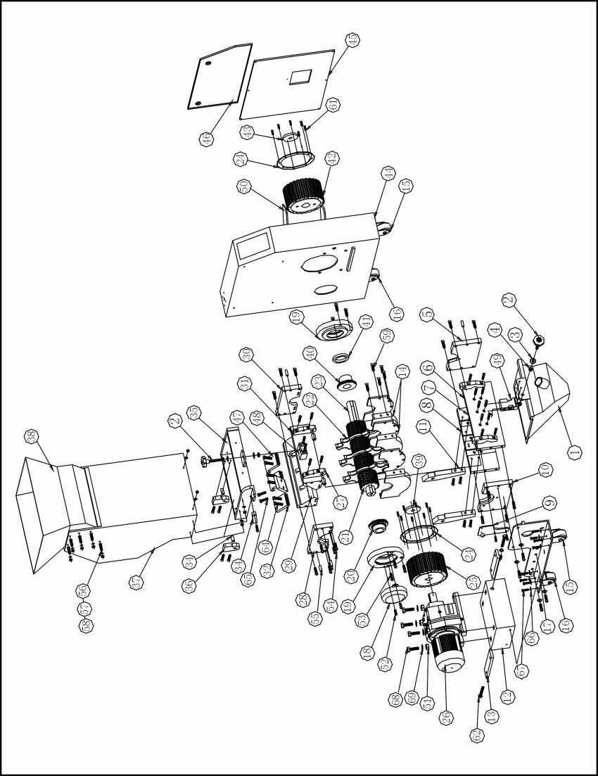

Note: Please refer to 2.3.6 material list about the parts code.

Picture 2-7：Assembly Drawing (SG-2436(H))

Table 2-4：Parts List (SG-2436)

No. | Name | Part No. | No. | Name | Part No.
1 | Storage box | BL51243610020 |  | Fix the font blade F1 (6×7)* | YW40240700000
2 | Star knob** | BH11127000010 | 33 | Fix the back blade B(4×5.3)* | YW40241300000
3 | Gasket Ф12×24 | YW66123200100 |  | Fix the back blade B(5×5.3)* | YW40024000300
4 | Fastening screw M12 | YW64000300000 |  | Fix the back blade B (6×7)* | YW40240900000
5 | Right bottom bearing holder | BH10240000010 | 34 | Locating block (4) | BH10024000510
6 | Location block (1) | BH10024000110 | 35 | Bottom base of feed box | BH10243600210
7 | Front bottom housing | BH10243600610 | 36 | Locating block (5) | BH10024000510
8 | Back bottom housing | BH10243600010 | 37 | Feed box | YR90243600100
9 | Locating block (3) | BH10024000310 | 38 | Feed port | BL56243600020
10 | Left bottom bearing holder | BH10240000110 | 39 | Gasket 2 | BL51801200020
11 | Locating block (5) | BH10024000610 | 40 | Right bearing sleeve | YW30002400100
12 | Fixing block for gear motor | - | 41 | Stop ring | BH10002401110
13 | Position-adjusting plate | - | 42 | Synchronous pulley (1) | BW08245000010
14 | Interlayer | BH10002400810 | 43 | Gasket 1 | BL51802100020
15 | Fixed castor | YW03000300500 | 44 | Out housing | -
16 | Rotary castor | YW03000300200 | 45 | Top side plate | -
17 | Castor fixing plate | - | 46 | Top side plate | -
18 | Bearing cover | BL51002402420 | 47 | Fix the font blade F2(4×5.3)* | YW40241200000
19 | Left and right bearing block | BW30306000410 |  | Fix the font blade F2(5×5.3)* | YW40024000200
20 | Left bearing sleeve | YW30024000200 |  | Fix the font blade F2(6×7)* | YW40240800000
21 | Teeth cutter (4×5.3)* | YW40241400000 | 48 | Locating block (2) | BH10024000210
 | Teeth cutter (5×5.3)* | YW40024000400 | 49 | Safety switch | YE16147600100
 | Teeth cutter (6×7)* | YW40241000000 | 50 | Synchronal belt ** | YR00105800000
22 | Staggered blade* | YW40245000000 | 51 | Nuts M16 | YW64001600000
23 | Shaft | BH10243601010 | 52 | Inner hexagon screw | YW61053000100
24 | Synchronous pulley gasket | YW69012700000 | 53 | Inner hexagon screw | YW61124000000
25 | Synchronous pulley (2-1) | BW08244500010 | 54 | Inner hexagon screw | YW61103500000
26 | Gear motor (1.5kW) | YM10779000000 | 55 | spring positioning pin | YW69123500000
27 | Locating block (1) | BH10024000310 | 56 | Inner hexagon lentil heated screw | YW61082000300
28 | Left top bearing holder | BH10240000310 | 57 | Flat washer | YW66081900000
29 | Back top housing block | YW30243600400 | 58 | Loose-proof nut | YW64000800100
30 | Right bearing holder on top housing | BH10240000210 | 59 | Countersunk head screw | YW61082000100
31 | Front top housing block | BW30243600610 | 60 | Inner hexagon screw | YW61106500000
32 | Fix the font blade F1(4×5.3)* | YW40241100000 | 61 | Countersunk head screw | YW62051000100
 | Fix the font blade F1(5×5.3)* | YW40024000100 | 62 | Outer hexagon screw | YW60125000100

No. | Name | Part No. | No. | Name | Part No.
63 | Flat washer | YW66123200100 | 67 | Outer hexagon screw | YW60082000100
64 | Outer hexagon screw | YW60103500000 | 68 | Outer hexagon screw | YW60165000000
65 | Outer hexagon screw | YW60103000000 | 69 | Flat washer Ф16×32 | YW66164000000
66 | Flat washer | YW66081600000
* means possible broken parts.
** means easy broken part. and spare backup is suggested.
Please confirm the version of manual before placing the purchase order to guarantee that the item number of the spare part is in accordance with the real object.

Table 2-5：Parts List (SG-2436H)

No. | Name | Part No. | No. | Name | Part No.
1 | Storage box | BL51243610020 | 33 | Fix the back blade B (4×5.3)* | YW40241300000
2 | Star knob** | BH11127000010 |  | Fix the back blade B (5×5.3)* | YW40024000300
3 | Gasket Ф12×24 | YW66123200100 |  | Fix the back blade B (6×7)* | YW40240900000
4 | Fastening screw M12 | YW64000300000 | 34 | Locating block (4) | BH10024000510
5 | Right bottom bearing holder | BH10240000010 | 35 | Bottom base of feed box | BH10243600210
6 | Location block (1) | BH10024000110 | 36 | Locating block (5) | BH10024000510
7 | Front bottom housing | BH10243600610 | 37 | Feed box | YR90243600100
8 | Back bottom housing | BH10243600010 | 38 | Feed port | BL56243600020
9 | Locating block (3) | BH10024000310 | 39 | Gasket 2 | BL51801200020
10 | Left bottom bearing holder | BH10240000110 | 40 | Right bearing sleeve | YW30002400100
11 | Locating block (5) | BH10024000610 | 41 | Stop ring | BH10002401110
12 | Fixing block for gear motor | - | 42 | Synchronous pulley (1) | BW08245000010
13 | Position-adjusting plate | - | 43 | Gasket 1 | BL51802100020
14 | Interlayer | BH10002400810 | 44 | Out housing | -
15 | Fixed castor | YW03000300500 | 45 | Top side plate | -
16 | Rotary castor | YW03000300200 | 46 | Top side plate | -
17 | Castor fixing plate | - | 47 | Fix the font blade F2 (4×5.3)* | YW40241200000
18 | Bearing cover | BL51002402420 |  | Fix the font blade F2 (5×5.3)* | YW40024000200
19 | Left and right bearing block | BW30306000410 |  | Fix the font blade F2 (6×7)* | YW40240800000
20 | Left bearing sleeve | YW30024000200 | 48 | Locating block (2) | BH10024000210
21 | Teeth cutter (4×5.3)* | YW40241400000 | 49 | Safety switch | YE16147600100
 | Teeth cutter (5×5.3)* | YW40024000400 | 50 | Synchronal belt ** | YR00105800000
 | Teeth cutter (6×7)* | YW40241000000 | 51 | Nuts M16 | YW64001600000
22 | Staggered blade* | YW40245000000 | 52 | Inner hexagon screw | YW61053000100
23 | Shaft | BH10243601010 | 53 | Inner hexagon screw | YW61124000000
24 | Synchronous pulley gasket | YW69012700000 | 54 | Inner hexagon screw | YW61103500000
25 | Synchronous pulley (2-1) | BW08244500010 | 55 | spring positioning pin | YW69123500000
26 | Gear motor (2.2kW) | YM10871000000 | 56 | Inner hexagon lentil heated screw | YW61082000300
27 | Locating block (1) | BH10024000310 | 57 | Flat washer | YW66081900000
28 | Left top bearing holder | BH10240000310 | 58 | Loose-proof nut | YW64000800100
29 | Back top housing block | YW30243600400 | 59 | Countersunk head screw | YW61082000100
30 | Right bearing holder on top housing | BH10240000210 | 60 | Inner hexagon screw | YW61106500000
31 | Front top housing block | BW30243600610 | 61 | Countersunk head screw | YW62051000100
32 | Fix the font blade F1(4×5.3)* | YW40241100000 | 62 | Outer hexagon screw | YW60125000100
 | Fix the font blade F1(5×5.3)* | YW40024000100 | 63 | Flat washer | YW66123200100
 | Fix the font blade F1(6×7)* | YW40240700000 | 64 | Outer hexagon screw | YW60103500000

31(83)

No. | Name | Part No. | No. | Name | Part No.
65 | Outer hexagon screw | YW60103000000 | 68 | Outer hexagon screw | YW60165000000
66 | Flat washer | YW66081600000 | 69 | Flat washer Ф16×32 | YW66164000000
67 | Outer hexagon screw | YW60082000100
* means possible broken parts.
** means easy broken part. and spare backup is suggested.
Please confirm the version of manual before placing the purchase order to guarantee that the item number of the spare part is in accordance with the real object.

2.3.7 Assembly Drawing (SG-2446)

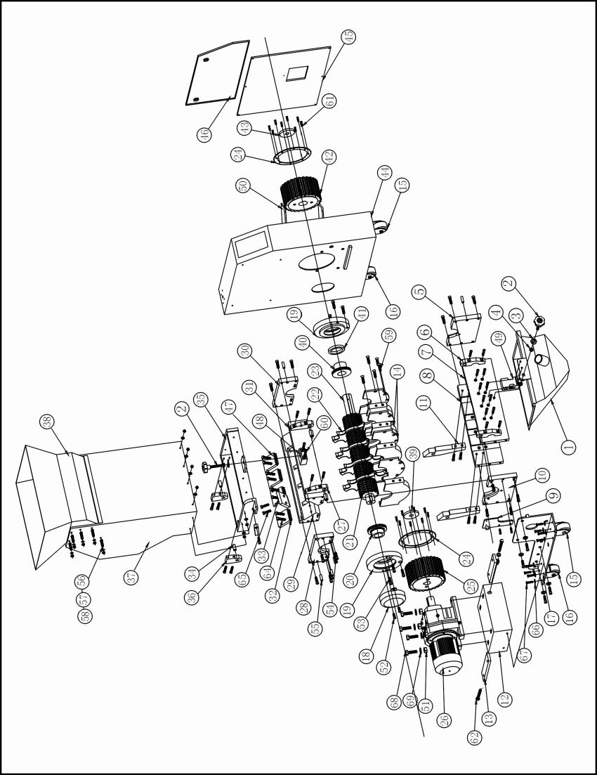

Note: Please refer to 2.3.8 material list about the parts code.

Picture 2-8：Assembly Drawing (SG-2446)

Table 2-6：Parts List (SG-2446)

No. | Name | Part No. | No. | Name | Part No.
1 | Storage box | BL51244610020 |  | Fix the font blade F1 (5×5.3)* | YW40024000100
2 | Star knob | BH11127000010 |  | Fix the font blade F1 (6×7)* | YW40240700000
3 | Gasket Ф12×24 | YW66123200100 | 33 | Fix the back blade B (4×5.3)* | YW40241300000
4 | Fastening screw M12 | YW64000300000 |  | Fix the back blade B (4×5.3)* | YW40241300000
5 | Right bottom bearing holder | BH10240000010 |  | Fix the back blade B (6×7)* | YW40240900000
6 | Location block (1) | BH10024000110 |  | Fix the back blade B (5×5.3)* | YW40024000300
7 | Front bottom housing | BH10244600410 | 34 | Locating block (4) | BH10024000510
8 | Back bottom housing | BH10244600310 | 35 | Bottom base of feed box | BH10244600610
9 | Locating block (3) | BH10024000310 | 36 | Locating block (5) | BH10024000510
10 | Left bottom bearing holder | BH10240000110 | 37 | Feed box | BL55364500220
11 | Locating block (5) | BH10024000610 | 38 | Feed port | BL56244600020
12 | Fixing block for gear motor | - | 39 | Gasket 2 | BL51801200020
13 | Position-adjusting plate | BH10214500010 | 40 | Right bearing sleeve | YW30002400100
14 | Interlayer | BH10002400810 | 41 | Stop ring | BH10002401110
15 | Fixed castor | YW03000300500 | 42 | Synchronous pulley (1) | BW08245000010
16 | Rotary castor | YW03000300200 | 43 | Gasket 1 | BL51802100020
17 | Castor fixing plate | - | 44 | Out housing | -
18 | Bearing cover | BL51002402420 | 45 | Top side plate | -
19 | Left and right bearing block | BW30306000410 | 46 | Top side plate | -
20 | Left bearing sleeve | YW30024000200 | 47 | Fix the font blade F2 (4×5.3)* | YW40241200000
21 | Teeth cutter (4×5.3)* | YW40241400000 |  | Fix the font blade F2 (5×5.3)* | YW40024000200
 | Teeth cutter (5×5.3)* | YW40024000400 |  | Fix the font blade F2 (6×7)* | YW40240800000
 | Teeth cutter (6×7)* | YW40241000000 | 48 | Locating block (2) | BH10024000210
22 | Staggered blade* | YW40245000000 | 49 | Safety switch | YE16147600100
23 | Shaft | BH10244601010 | 50 | Synchronal belt ** | YR00105800000
24 | Synchronous pulley gasket | YW69012700000 | 51 | Nuts M16 | YW64001600000
25 | Synchronous pulley (2-1) | BW08244500010 | 52 | Inner hexagon screw | YW61053000100
26 | Gear motor (2.2kW) | YM10871000000 | 53 | Inner hexagon screw | YW61124000000
27 | Locating block (1) | BH10024000310 | 54 | Inner hexagon screw | YW61103500000
28 | Left top bearing holder | BH10240000210 | 55 | spring positioning pin Ф12×35 | YW69123500000
29 | Back top housing block | YW30243600500 | 56 | Inner hexagon lentil heated screw | YW61082000300
30 | Right bearing holder on top housing | BH10240000210 | 57 | Flat washer ф8×18 | YW66081900000
31 | Front top housing block | YW30244600400 | 58 | Loose-proof nut M8 | YW64000800100
32 | Fix the font blade F1(4×5.3)* | YW40241100000 | 59 | Countersunk head screw  M8×20 | YW61082000100

No. | Name | Part No. | No. | Name | Part No.
60 | Inner hexagon screw  M10×60 | YW61106500000 | 65 | Outer hexagon screw M10×30 | YW60103000000
61 | Countersunk head screw  M5×10 | YW62051000100 | 66 | Flat washer ф8×16 | YW66081600000
62 | Outer hexagon screw  M12×55 | YW60125000100 | 67 | Outer hexagon screw M8×20 | YW68061000000
63 | Flat washer ф12×32 | YW66123200100 | 68 | Outer hexagon screw M16×50 | YW60165000000
64 | Outer hexagon screw  M10×35 | YW60103500000 | 69 | Flat washer Ф16×32 | YW66164000000
* means possible broken parts.
** means easy broken part. and spare backup is suggested.
Please confirm the version of manual before placing the purchase order to guarantee that the item number of the spare part is in accordance with the real object.

2.3.9 Cutting Chamber

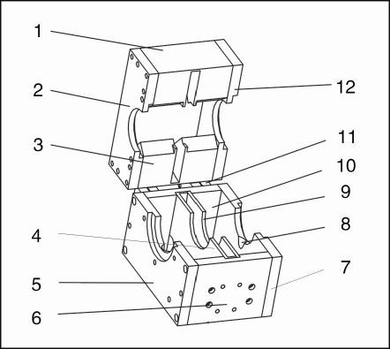

Picture 2-9：Cutting Chamber
2.3.10 Cutting Chamber Parts List

Table 2-7：Cutting Chamber Parts List

No. | Name | Quantity
 |  | SG-2417 | SG-2427 | SG-2436 | SG-2446
1 | Front top housing block | 1 | 1 | 1 | 1
2 | Left top bearing holder | 1 | 1 | 1 | 1
3 | Back top housing block | 1 | 1 | 1 | 1
4 | Interlayer 1 | 1 | 2 | 3 | 4
5 | Left bottom bearing holder | 1 | 1 | 1 | 1
6 | Front bottom housing block | 1 | 1 | 1 | 1
7 | Right bottom bearing holder | 1 | 1 | 1 | 1
8 | Air exhaust | 1 | 1 | 1 | 1
9 | Interlayer 2 | 1 | 2 | 3 | 4
10 | Back bottom housing block | 1 | 1 | 1 | 1
11 | Locating block | 1 | 1 | 1 | 1
12 | Right top bearing holder | 1 | 1 | 1 | 1

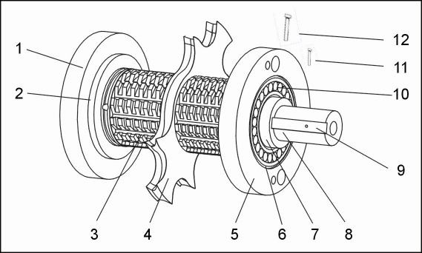

Picture 2-10：Blade Rest
2.3.11.1 Blade Rest Parts List

Table 2-8：Blade Rest Parts List

No. | Name | Quantity
 |  | SG-2417 | SG-2427 | SG-2436 | SG-2446
1 | Left bearing block | 1 | 1 | 1 | 1
2 | Left bearing sleeve | 1 | 1 | 1 | 1
3 | Teeth cutter | 2 | 3 | 4 | 5
4 | Staggered blade | 1 | 2 | 3 | 4
5 | Right bearing block | 1 | 1 | 1 | 1
6 | Spring ring | 2 | 2 | 2 | 2
7 | Right bearing block | 1 | 1 | 1 | 1
8 | Shaft | 1 | 1 | 1 | 1
9 | Key | 1 | 1 | 1 | 1
10 | Bearing | 2 | 2 | 2 | 2
11 | Lockup screw | 6 | 6 | 6 | 6
12 | Fixing screw | 6 | 6 | 6 | 6

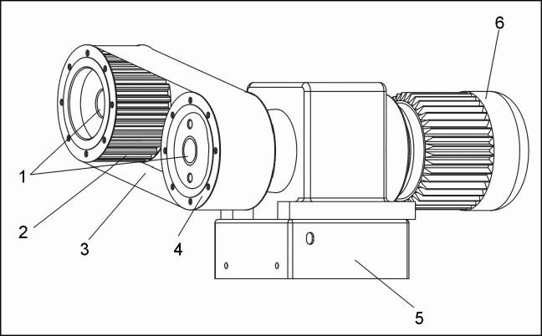
Picture 2-11：Transmission Parts
2.3.13 Transmission Parts List

Table 2-9：Transmission Parts List

No. | Name | Quantity
 |  | SG-2417 | SG-2427 | SG-2436 | SG-2446
1 | Lock ring for synchronous pulley | 2 | 2 | 2 | 2
2 | Synchronous pulley (1) | 1 | 1 | 1 | 1
3 | Tooth belt | 1 | 1 | 1 | 1
4 | Synchronous pulley (2) | 1 | 1 | 1 | 1
5 | Gear motor base | 1 | 1 | 1 | 1
6 | Gear motor | 1 | 1 | 1 | 1

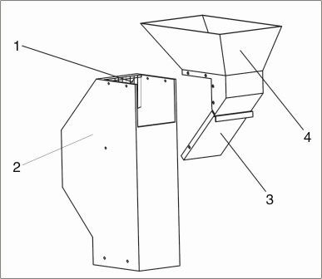
Picture 2-12：Feed Box, Sound Insulation Box and Check Plate
2.3.15 Feed Box, Sound Insulation Box and Check Plate Parts List

Table 2-10：Feed Box, Sound Insulation Box and Check Plate Parts List

No. | Name | Quantity
 |  | SG-2417 | SG-2427 | SG-2436 | SG-2446
1 | Material check stripes | 1 | 1 | 1 | 1
2 | Feed box | 1 | 1 | 1 | 1
3 | Check plate | 1 | 1 | 1 | 1
4 | Feed port | 1 | 1 | 1 | 1
2.3.16 Storage Box

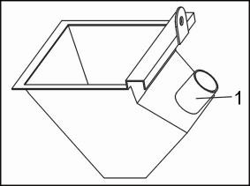

Picture 2-13：Storage Box
2.3.17 Storage Box Parts List

Table 2-11：Storage Box Parts List

No. | Name | Quantity
 |  | SG-2417 | SG-2427 | SG-2436 | SG-2446
1 | Extraction pipe | 1.5'' | 1.5'' | 1.5'' | 1.5''

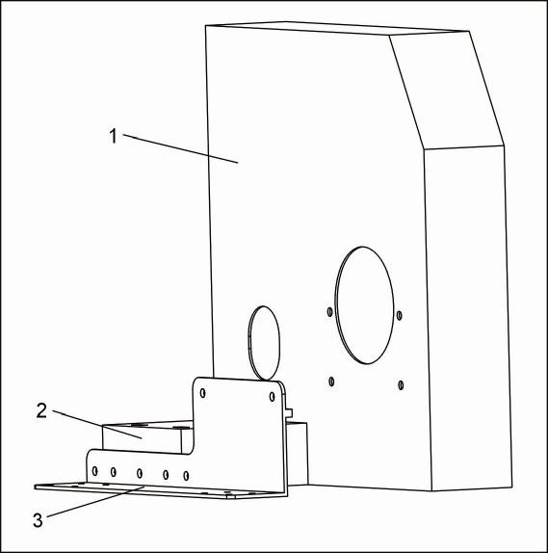

2.3.19 Main Body Parts List
Picture 2-14：Main Body

Table 2-12：Main Body Parts List

No. | Name | Quantity
 |  | SG-2417 | SG-2427 | SG-2436 | SG-2446
1 | Out housing | 1 | 1 | 1 | 1
2 | Motor fixing plate | 1 | 1 | 1 | 1
3 | Castor fixing plate | 1 | 1 | 1 | 1

2.4 Electrical Diagram

2.4.1 Main Circuit (400V)

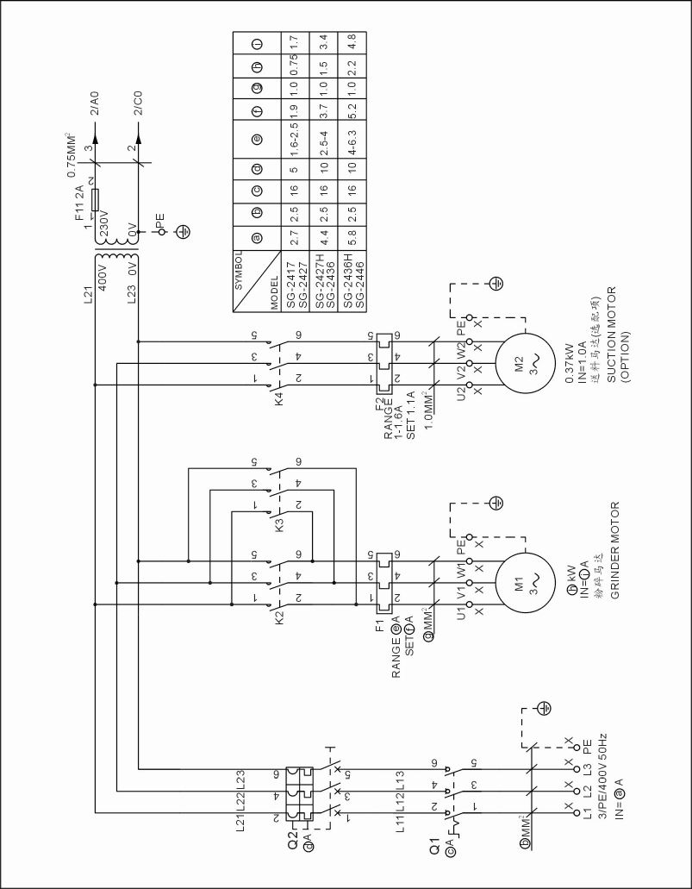

Picture 2-15：Main Circuit (400V)

2.4.2 Control Circuit Diagram (400V)

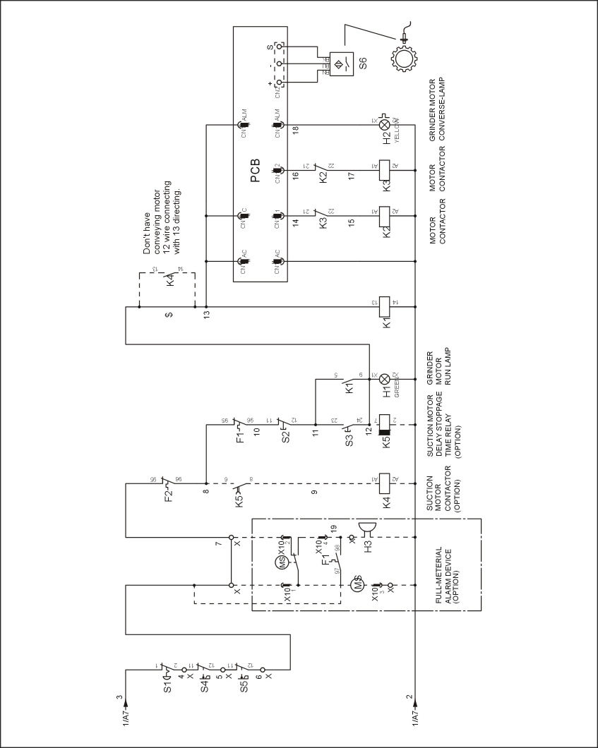

Picture 2-16：Control Circuit Diagram (400V)

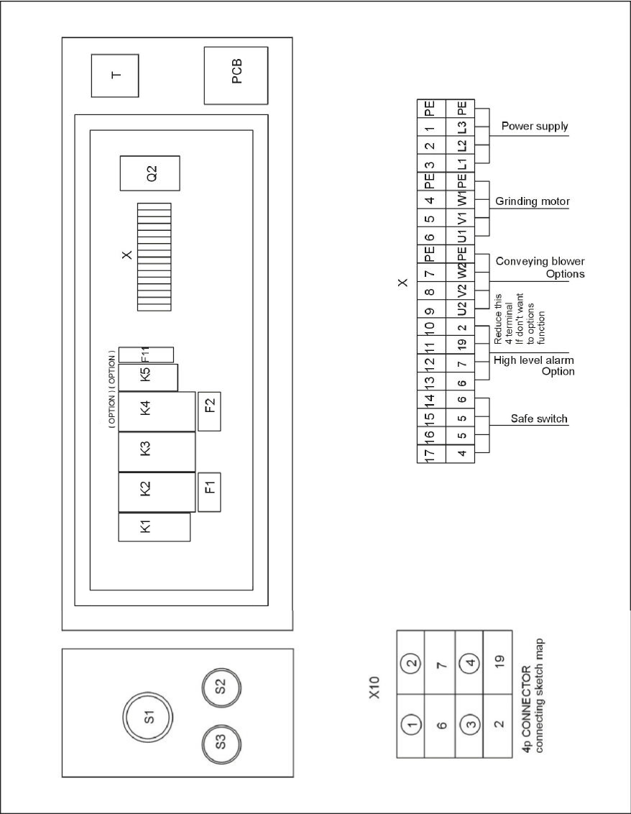

Picture 2-17：Components Layout (400V)

Table 2-13：Electrical Components List of SG-2417/2427 (400V)

NO. | Symbol | Name | Specification | Part NO.
1 | Q1 | Main switch | 16A 690V 3P | YE10200300000
2 | Q2 | Circuit breaker* | 5A 400V 3P | YE40603000000
3 | K1 | Middle relay* | 5A 2P 230V 50/60Hz | YE03570700000
4 | K2,K3 | Contactor* | 9A 3P 1NC 230V 50/60Hz | YE00300100000
5 | K4 | Contactor* | 9A 3P 1NO 230V 50/60Hz | YE00301000000
6 | K5 | Timer* | 230V 50/60Hz | YE86000300000
7 | F1 | Overload relay* | 1.6~2.5A | YE01162500000
8 | F2 | Overload relay* | 1~1.6A | YE01011600000
9 | T | Transformer* | IN=400V OUT=230V 300mA | YE70402300700
10 | PCB | PCB* | 230VAC AC-01 | YE80012200200
11 | F11 | Fuse** | 2A 250VAC | YE41001000000
12 | X1 | Terminal board | 32A | YE61250000000
13 | - | - | - | YE61253500000
14 | H2 | Alarm lamp | 230VAC 50/60Hz | YE83305100200
15 | H3 | Buzzer | 220VAC | YE84222000000
16 | X10 | Metal tie in | 4P | YE10121900000  YE10220600000
17 | S1 | Emergency stop button | 400V AC12 10A | YE11320300000
18 | S2 | Stop button | 400V AC12 10A | YE11375800000
19 | S3,H1 | Start button | 400V AC12 10A | YE11325300000
20 | S4,S5 | Safety switch | AZ-15 | YE16147600100
21 | S6 | Sensor* | 24VDC NPN | YE15122400000
22 | MS | Feed position motor | 3A/250V | YE15000200100
23 | M1 | Granulating motor | 230V 400V 50Hz 0.75kW | YM10578000000
24 | M2 | Conveying blower | 230V 400V 50Hz 0.37kW | BM30010200250
* means possible broken parts.
** means easy broken part. and spare backup is suggested.
Please confirm the version of manual before placing the purchase order to guarantee that the item number of the spare part is in accordance with the real object.

NO. | Symbol | Name | Specification | Part NO.
1 | Q1 | Main switch | 16A 690V 3P | YE10200300000
2 | Q2 | Circuit breaker* | 10A 400V 3P | YE40600300000
3 | K1 | Middle relay* | 5A 2P 230V 50/60Hz | YE03570700000
4 | K2,K3 | Contactor* | 9A 3P 1NC 230V 50/60Hz | YE00300100000
5 | K4 | Contactor* | 9A 3P 1NO 230V 50/60Hz | YE00301000000
6 | K5 | Timer* | 230V 50/60Hz | YE86000300000
7 | F1 | Overload relay* | 2.5~4A | YE01025400000
8 | F2 | Overload relay* | 1~1.6A | YE01011600000
9 | T | Transformer* | IN=400V OUT=230V 300mA | YE70402300700
10 | PCB | PCB* | 230VAC AC-01 | YE80012200200
11 | F11 | Fuse** | 2A 250VAC | YE41001000000
12 | X1 | Terminal board | 32A | YE61250000000
13 | - | - | - | YE61253500000
14 | H2 | Alarm lamp | 230VAC 50/60Hz | YE83305100200
15 | H3 | Buzzer | 220VAC | YE84222000000
16 | X10 | Metal tie in | 4P | YE10121900000  YE10220600000
17 | S1 | Emergeney stop button | 400V AC12 10A | YE11320300000
18 | S2 | Stop button | 400V AC12 10A | YE11375800000
19 | S3,H1 | Start button | 400V AC12 10A | YE11325300000
20 | S4,S5 | Safety switch | AZ-15 | YE16147600100
21 | S6 | Sensor* | 24VDC NPN | YE15122400000
22 | MS | Feed position motor | 3A/250V | YE15000200100
23 | M1 | Granulating motor | 230V 400V 50Hz 1.5kW | YM10779000000
24 | M2 | Conveying blower | 230V 400V 50Hz 0.37kW | BM30010200250
* means possible broken parts.
** means easy broken part. and spare backup is suggested.
Please confirm the version of manual before placing the purchase order to guarantee that the item number of the spare part is in accordance with the real object.

NO. | Symbol | Name | Specification | Part NO.
1 | Q1 | Main switch | 16A 690V 3P | YE10200300000
2 | Q2 | Circuit breaker* | 10A 400V 3P | YE40600300000
3 | K1 | Middle relay* | 5A 2P 230V 50/60Hz | YE03570700000
4 | K2,K3 | Contactor* | 9A 3P 1NC 230V 50/60Hz | YE00300100000
5 | K4 | Contactor* | 9A 3P 1NO 230V 50/60Hz | YE00301000000
6 | K5 | Timer* | 230V 50/60Hz | YE86000300000
7 | F1 | Overload relay* | 4~6.3A | YE01046300100
8 | F2 | Overload relay* | 1~1.6A | YE01011600000
9 | T | Transformer* | IN=400V OUT=230V 300mA | YE70402300700
10 | PCB | PCB* | 230VAC AC-01 | YE80012200200
11 | F11 | Fuse** | 2A 250VAC | YE41001000000
12 | X1 | Terminal board | 32A | YE61250000000
13 | - | - | - | YE61253500000
14 | H2 | Alarm lamp | 230VAC 50/60Hz | YE83305100200
15 | H3 | Buzzer | 220VAC | YE84222000000
16 | X10 | Metal tie in | 4P | YE10121900000  YE10220600000
17 | S1 | Emergeney stop button | 400V AC12 10A | YE11320300000
18 | S2 | Stop button | 400V AC12 10A | YE11375800000
19 | S3,H1 | Start button | 400V AC12 10A | YE11325300000
20 | S4,S5 | Safety switch | AZ-15 | YE16147600100
21 | S6 | Sensor* | 24VDC NPN | YE15122400000
22 | MS | Feed position motor | 3A/250V | YE15000200100
23 | M1 | Granulating motor | 230V 400V 50Hz 2.2kW | YM10871000000
24 | M2 | Conveying blower | 230V 400V 50Hz 0.37kW | BM30010200250
* means possible broken parts.
** means easy broken part. and spare backup is suggested.
Please confirm the version of manual before placing the purchase order to guarantee that the item number of the spare part is in accordance with the real object.

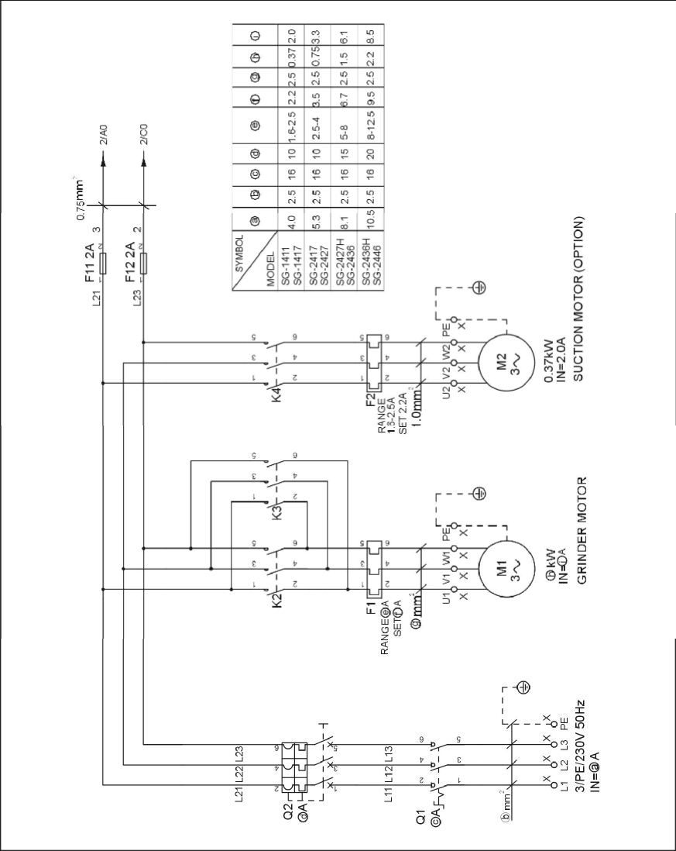

Picture 2-18：Main Electrical Circuit (230V)

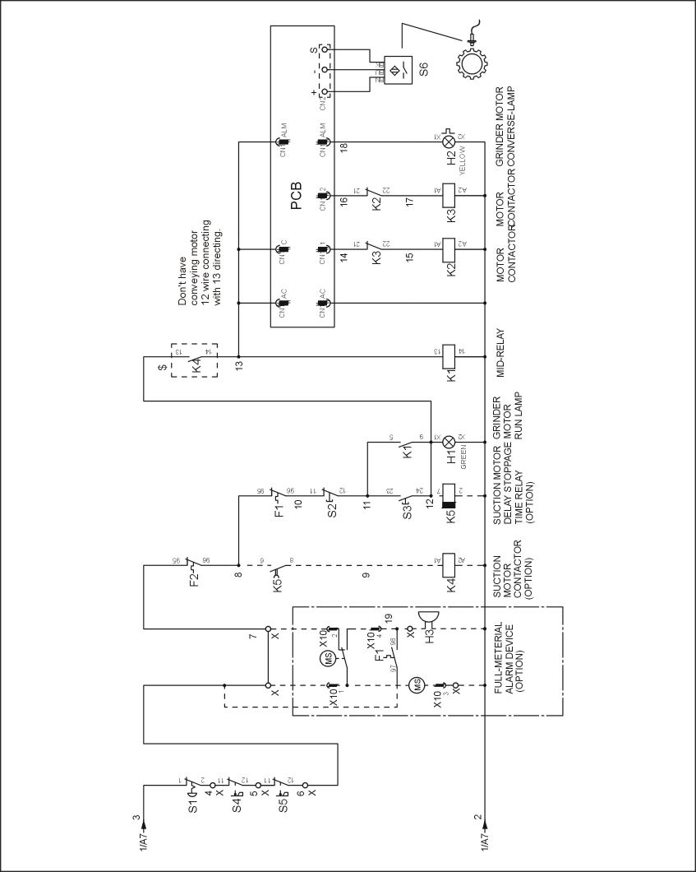

Picture 2-19：Control Circuit Diagram (230V)

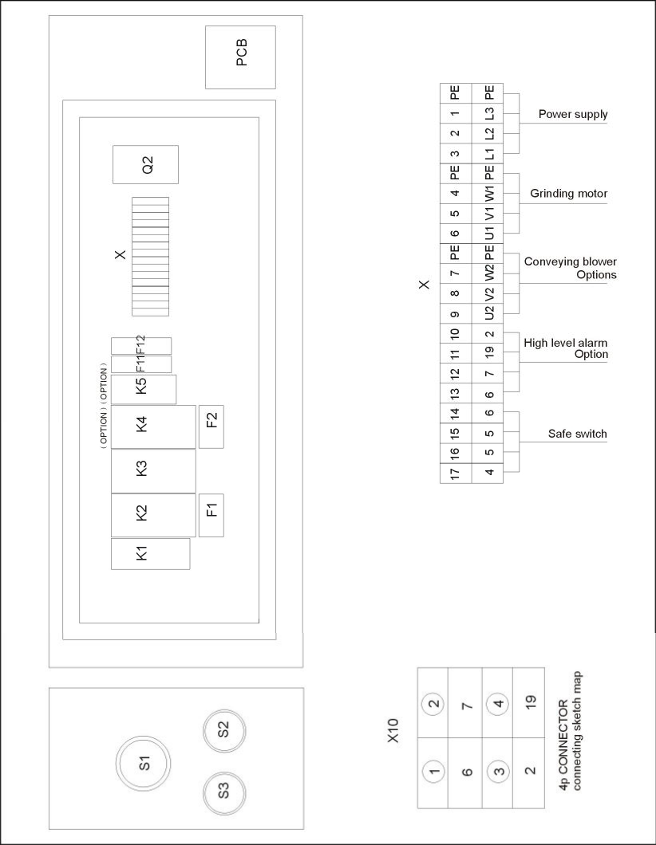

Picture 2-20：Components Layout (230V)

Table 2-16：Electrical Components List of SG-2417/2427 (230V)

NO. | Symbol | Name | Specification | Part NO.
1 | Q1 | Main switch | 16A | YE10200300000
2 | Q2 | Circuit breaker* | 10A | YE40600300000
3 | K1 | Middle relay* | 230V 50/60Hz | YE03570700000
4 | K2,K3 | Contactor* | 230V 50/60Hz | YE00300100000
5 | K4 | Contactor* | 230V 50/60Hz | YE00301000000
6 | K5 | Timer* | 230V 50/60Hz | YE86000300000
7 | F1 | Overload relay* | 2.5~4A | YE01025400000
8 | F2 | Overload relay* | 1.6~2.5A | YE01162500000
9 | PCB | PCB* | 230VAC | YE80012200200
10 | F11 F12 | Fuse** | 2A | YE41001000000
11 | X1 | Terminal board | 32A | YE61250000000
12 | - | - | - | YE61253500000
13 | H2 | Alarm lamp | 220VAC 50/60Hz | YE83305100200
14 | H3 | Buzzer | 220VAC | YE84222000000
15 | X10 | Metal tie in | 4P | YE10121900000  YE10220600000
16 | S1 | Emergency stop button | 400V AC12 10A | YE11320300000
17 | S2 | Stop button | 400V AC12 10A | YE11375800000
18 | S3,H1 | Start button | 400V AC12 10A | YE11325300000
19 | S4,S5 | Safety switch | AZ-15 | YE16147600100
20 | S6 | Sensor* | 24VDC NPN | YE15122400000
21 | MS | Feed position motor | 3A/250V | YE15000200100
22 | M1 | Granulating motor | 230V 400V 50Hz 0.75kW | YM10578000000
23 | M2 | Solution blower | 230V 400V 50Hz 0.37kW | BM30010200250
* means possible broken parts.
** means easy broken part. and spare backup is suggested.
Please confirm the version of manual before placing the purchase order to guarantee that the item number of the spare part is in accordance with the real object.

NO. | Symbol | Name | Specification | Part NO.
1 | Q1 | Main switch | 16A | YE10200300000
2 | Q2 | Circuit breaker* | 15A | YE40601500000
3 | K1 | Middle relay* | 230V 50/60Hz | YE03570700000
4 | K2,K3 | Contactor* | 230V 50/60Hz | YE00300100000
5 | K4 | Contactor* | 230V 50/60Hz | YE00301000000
6 | K5 | Timer* | 230V 50/60Hz | YE86000300000
7 | F1 | Overload relay* | 5~8A | YE01050800000
8 | F2 | Overload relay* | 1.6~2.5A | YE01162500000
9 | PCB | PCB* | 230VAC | YE80012200200
10 | F11 F12 | Fuse** | 2A | YE41001000000
11 | X1 | Terminal board | 32A | YE61250000000
12 | - | - | - | YE61253500000
13 | H2 | Alarm lamp | 220VAC 50/60Hz | YE83305100200
14 | H3 | Buzzer | 220VAC | YE84222000000
15 | X10 | Metal tie in | 4P | YE10121900000  YE10220600000
16 | S1 | Emergeney stop button | 400V AC12 10A | YE11320300000
17 | S2 | Stop button | 400V AC12 10A | YE11375800000
18 | S3,H1 | Start button | 400V AC12 10A | YE11325300000
19 | S4,S5 | Safety switch | AZ-15 | YE16147600100
20 | S6 | Sensor* | 24VDC NPN | YE15122400000
21 | MS | Feed position motor | 3A/250V | YE15000200100
22 | M1 | Granulating motor | 230V 400V 50Hz 1.5kW | YM10779000000-
23 | M2 | Solution blower | 230V 400V 50Hz 0.37kW | BM30010200250
* means possible broken parts.
** means easy broken part. and spare backup is suggested.
Please confirm the version of manual before placing the purchase order to guarantee that the item number of the spare part is in accordance with the real object.

NO. | Symbol | Name | Specification | Part NO.
1 | Q1 | Main switch | 16A | YE10200300000
2 | Q2 | Circuit breaker* | 20A | YE40602000000
3 | K1 | Middle relay* | 230V 50/60Hz | YE03570700000
4 | K2,K3 | Contactor* | 230V 50/60Hz | YE81023000000
5 | K4 | Contactor* | 230V 50/60Hz | YE00301000000
6 | K5 | Timer* | 230V 50/60Hz | YE86000300000
7 | F1 | Overload relay* | 8~12.5A | YE01812500000
8 | F2 | Overload relay* | 1.6~2.5A | YE01162500000
9 | PCB | PCB* | 230VAC | YE80012200200
10 | F11 F12 | Fuse** | 2A | YE41001000000
11 | X1 | Terminal board | 32A | YE61250000000
12 | - | - | - | YE61253500000
13 | H2 | Alarm lamp | 220VAC 50/60Hz | YE83305100200
14 | H3 | Buzzer | 220VAC | YE84222000000
15 | X10 | Metal tie in | 4P | YE10121900000  YE10220600000
16 | S1 | Emergeney stop button | 400V AC12 10A | YE11320300000
17 | S2 | Stop button | 400V AC12 10A | YE11375800000
18 | S3,H1 | Start button | 400V AC12 10A | YE11325300000
19 | S4,S5 | Safety switch | AZ-15 | YE16147600100
20 | S6 | Sensor* | 24VDC NPN | YE15122400000
21 | MS | Feed position motor | 3A/250V | YE15000200100
22 | M1 | Granulating motor | 230V 400V 50Hz 2.2kW | YM10871000000
23 | M2 | Solution blower | 230V 400V 50Hz 0.37kW | BM30010200250
* means possible broken parts.
** means easy broken part. and spare backup is suggested.
Please confirm the version of manual before placing the purchase order to guarantee that the item number of the spare part is in accordance with the real object.

2.5 Electrical Components Description

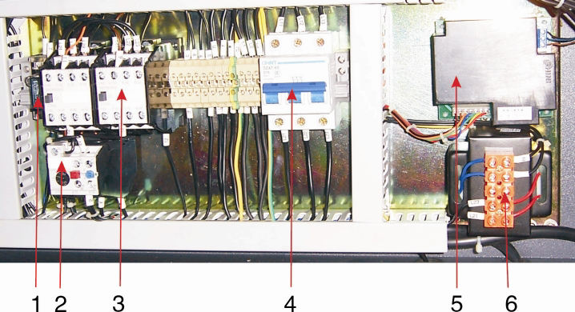

Picture 2-21：Electrical Components Description
1. Fuse, which performs the function of overload and short circuit protection.
2. Electromagnetic switch, which can connect or disconnect the power from remote.
3. Thermo overload relay, which can protect the motor when they are overloading or phase opening.
4. Circuit breaker, which performs the function of short circuit protection or circuit isolation.
5. Reversed PCB.
6. Transformer，which provide suitable voltage for the control circuit.

2.6 Optional Accessories

2.6.1 30 seconds Instant Recycling System

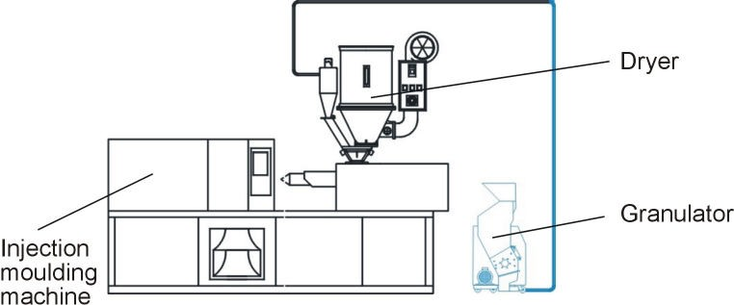

Picture 2-22：30 seconds Instant Recycling System

2.6.2 Manual Collective Storage Box

Picture 2-23：Manual Collective Storage Box

2.6.3 Full Material Alarming Device

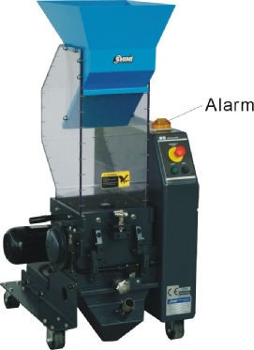
Picture 2-24：Alarm

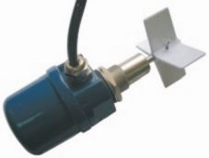

Picture 2-25：Material level motor

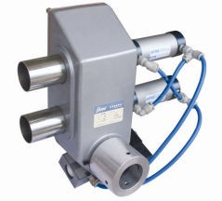2.6.4 Proportional Valve

Picture 2-26：Control Box, Valve body

3. Installation and Debugging

Read through this chapter before installation.

Must abide the following installation stepts to avoid personnel injuries or damage of the machine!

Take great care of handing the blades because they are very sharp and may cause cutting injuries!

Power supply of the machine should be handled by qualified electricians!

Be careful!

Cutting blades must be put balanced, prevent it to rotate itself when do the installation. Keep hands from blades to avoid body injuries!
Attention:

Don't take other person's help to finish the installation, use a wooden board to block the rotating blade to finish it.
Notice!
Use protective gloves since the blades are very sharp.

Caution!
Must use new screw and washer to install the blade.

3.1 Installation Notice

1) Make sure voltage and frequency of the power source comply with those indicated on the manufacture's plate, which is attached to the machine.
2) Power cable and earth connections should conform with local regulations.
3) Use independent power cable and ON / OFF switch. The cable's dia. Should not smaller than those applied in the control box.
4) The power cable connection terminals should be tightened securely.
5) The machine requires a 3-phase 4-wire power source, connect the power lead
(L1, L2, L3) to the live wires, and the earth (PE) to the ground.
6) Power supply requirements: Main power voltage: +/- 10% Main power frequency: +/- 2%
Make at least 1 meter clearance around the machine to facilitate repair and maintenance.

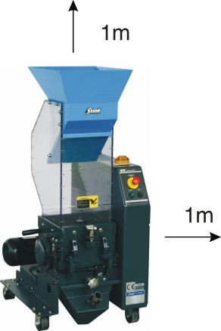

Picture 3-1：Installation Space

Table 3-1：Attached Form: cutters and Other Fixing Screw Torque

Thread size | M10 | M12 | M14 | M16 | M18 | M20 | M22 | M24
Axial force(N) | 23.8 | 34.5 | 47 | 65.5 | 78.5 | 103 | 129 | 149
Fixing torque (Nm) | 50 | 86 | 135 | 215 | 290 | 420 | 570 | 730

3.2 Installation Place

Check and make sure the installation ground is level; there is enough intensity when it is running. Lockup the castors.

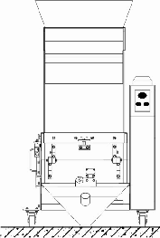

Picture 3-2：Installation Place
3.3 Installation of Bearing and Blade Rest

1) Install the bearing 2, bearing washer 1, bearing sleeve 7 into the bearing base 3.
2) Insert the blade shaft4into the bearing sleeve vertically 7.Then sleeve the staggered blade 5 and the teeth blade 6 on the bearing spacing.

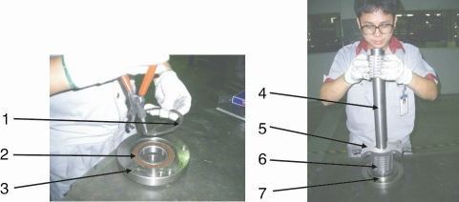

Picture 3-3：Installation of Bearing and Blade Rest 1

3) Put the blade rest 2 into the cutting chamber 1, Let both terminal of the bearing tallies with the grooves.

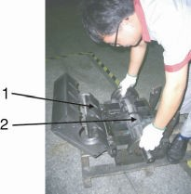

Picture 3-4：Installation of Bearing and Blade Rest 2

4) Fix the bearing base on the cutting chamber

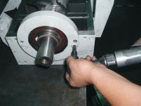

Picture 3-5：Installation of Bearing and Blade Rest 3

Notice!
Daub the lubrication on the bearing and bearing base. Use proper twisting force to lock the screw tightly.

3.4 Installation of Belt Pulley and Motor

Notice!

When mount synchronizing wheel, in order to prevent the blade rest from self-rotating, use a thick wood block to lock the rotating blades.

1) Firstly, mount the retainer ring on the synchronizing wheel, and put the synchronizing wheel 1 on knife shaft, align key way to the knife shaft, and mount on the key, then fix the synchronizing wheel with hexagon socket head cap screw and washer, then fasten screws (M16×45).

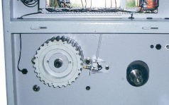

Picture 3-6：Installation of Belt Pulley and Motor 1
2) Use fastening (M14x50) to fix the motor on the bottom plate of the granulator.
In order to make adjustment later, don't tighten the screws right now.

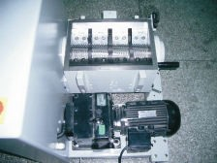

Picture 3-7：Installation of Belt Pulley and Motor 2

3) After centering motor shaft, put synchronizing wheel 2 to the motor, the
key-way should be aligned to motor shaft, then mount on the key and fix the synchronizing wheel with hexagon socket head cap screw and washer, then fasten screws (M16×45).

Picture 3-8：Installation of Belt Pulley and Motor 3
4) Put synchronizing belt on synchronizing wheel 1 and synchronizing wheel 2, the gears of synchronizing belt and synchronizing wheel should be meshing one to one. Manually rotate knife shaft and motor shaft, the gears of synchronizing belt and synchronizing wheel should be entire meshing, so the force given to them will be well-proportioned.

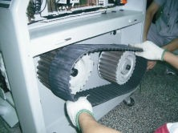

Picture 3-9：Installation of Belt Pulley and Motor 4
5) Tighten the bolt of motor belt-wheel, and move the belt wheel to its equilibrium position as much as possible.

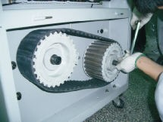

Picture 3-10：Installation of Belt Pulley and Motor 5
6) Place ruler near the plane of knife-shaft synchronizing wheel, observe the space between two synchronizing wheels and ruler, and at the same time, adjust the motor belt-wheel and make it to parallel the plane of synchronizing wheels.

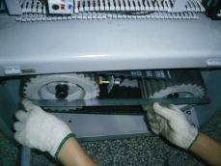

Picture 3-11：Installation of Belt Pulley and Motor 6
7) Use spanner to adjust the fastening screws of the motor to make the two belt pulleys parallel and tighten and maintain the motor level. Then tighten the screws to fix the motor on the bottom plate.

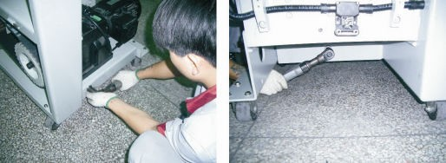

Picture 3-12：Installation of Belt Pulley and Motor 7

Note!
During installation or uninstallation the synchronous pulley, use a thick wooden block to seize the rotor to prevent its rotating.

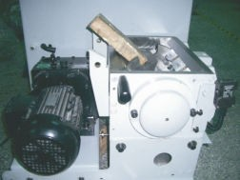

Picture 3-13：Installation of Belt Pulley and Motor 8
Be careful:
Cutters should be laid level and prevent the rotating of the rotor when install the blades. Keep hands away from the blades to avoid personal injuries.
3.5 Installation of Rotating Blade and Fixed Blade

1) Install the bearing 2, bearing washer 1, bearing sleeve 7 into the bearing base 3.

2) Insert the blade shaft 4 into the bearing sleeve vertically 7. Then sleeve the staggered blade 5 and the teeth blade 6 on the bearing spacing.

Picture 3-14：Installation of Rotating Blade and Fixed Blade 1

3) Put the rotating blade rest at the bottom block of the cutting chamber and align its holes with the holes on cutting chamber

Picture 3-15：Installation of Rotating Blade and Fixed Blade 2

4) Use a wrench to tight up all the screws on bearing block or cutting chamber and lock them up with right torque (M12x25).
5) After installed the rotating blade rest to the housing, mount fixed blades that correspond with teeth cutters on pressing block and align their holes. Lockup the fixing screw (LOCTITE243 thread fixing glue is recommended). (Fixing screw for front fixed blade is M10x30, while for back fixed blade is M10x35).

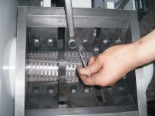

Picture 3-16：Installation of Rotating Blade and Fixed Blade 3

Caution!
In order to avoid personal injury and machine damage, the lockup screws has to be tightened.

3.6 Installation of Feed Box, Feed Port and Storage Box

1) Use screw and loose-proof- bolts firmly to fix the feeding box (M8×35).

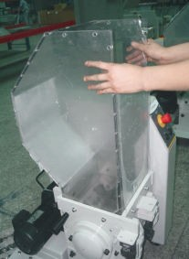

Picture 3-17：Installation of Feed Box, Feed Port and Storage Box 1
2) Hold the feed port and insert it along the feed port into the feed box.

Picture 3-18：Installation of Feed Box, Feed Port and Storage Box 2
3) Before fixing the feed port, place the plastic strips at the top of feed box and let feed port press against it.
4) After laying down the feed box, and align its screw holes with the screw holes on the feed box, then use screw and loose-proof- bolt to lock it tightly. (M8×20)

Picture 3-19：Installation of Feed Box, Feed Port and Storage Box 3
5) Hold the storage box with both hands and push it into its right position along the slide way.

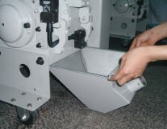

Picture 3-20：Installation of Feed Box, Feed Port and Storage Box 4
6) Lockup the star screw.

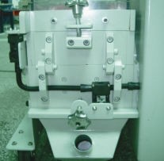

Picture 3-21：Installation of Feed Box, Feed Port and Storage Box 5

Note!
The parts of screw fallen into the teeth cutter chamber may be equipped with loose-proof bolt.

4. Operation Guide
Wear gloves during operating to avoid personal injury! Wear goggles during operating to avoid personal injury!

Because the blades and rotor may be loosen, check the following items before operating：
1) If the blade has any loose caused by damage.
2) If the rotor has any loose caused by damage.
If any of the above situation is found, please contact local representative or SHINI company for help.
4.1 Startup Pretest

Unpainted part of the machine has been covered with stainless oil. Before use, the stainless oil should be cleaned.

1) Clean with a towel
2) Wash with a towel dipping with amyl acetate.

4.1.1 Before the First Startup

1) Check whether the granulator is in the level state.
2) Check to see whether the lockup screws of the blades are tightened.

4.1.2 After First Startup for 2 Hours

1) Check the space of the cutting tools of the fixed blades and rotating blades again; check whether the lockup screws of the blades are loose.
2) Check the position-adjusting screws of the motor and check whether the position-adjusting screws are tightened.

4.1.3 After First Startup for 20~30 Hours

Check and adjust the belt's tensility after a 20~30 hour full-load operation.

4.2 Circuit Connection

The installation of the granulator's circuit must be conducted by the professional electricians.
1) Check whether the feed box is closed.
2) Check whether the storage box is closed.
3) Ensure the main power switch is in ON position.
4) Check the emergency stop.
5) Start the granulator via pressing the START button and stop the granulator via pressing the STOP button.
6) The granulator needs some time to fully come to a halt, after fully stop, check
whether the running direction is clockwise.

CAUTION: The cutting tools may be damaged and the granulating capability will be reduced if there is a wrong running direction. Please disconnect the power and transpose any two wires of the three in the main power.

4.3 Open the Feed Box and Storage Box

Before opening the feed box and the storage box, turn off the main power switch and the power switch of the granulator.
Be careful! The blade is very sharp, please take care.

4.3.1 Open the Feed Box

1) Check if the feed box has been emptied. If so, turn off the main power switch.
2) Loosen the long star screw.
3) Open the feed box backwardly.

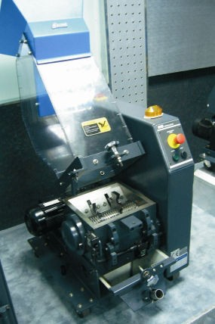

Picture 4-1：Open the Feed Box

4.3.2 Open the Storage Box

1) Shut off the power of granulator.
2) Loosen the long star screw.
3) Pull out the storage box.

The air spring is used only for installing the model SG-2446.

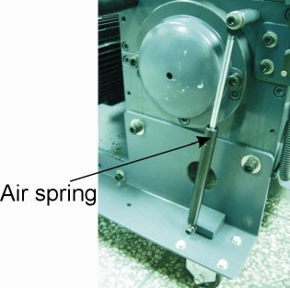

Picture 4-2：Air Spring

4.4 Shut the Feed Box and Storage Box

4.4.1 Close the Feed Box

Caution:
Make sure the feed box has been shut or the machine could not start.
1) Check to ensure there is no powder left in the interface or corners.
2) Close the feed box forwardly.
3) Lock up the star screw and fix the feed box.

4.4.2 Shut the Storage Box

Note!
Before closing, clean the interface surface. Be careful!
Don't get squeezed and injured.
1) Check no powder or leftover material around the cutting chamber and storage box; timely remove them if any.
2) Push the storage box along its slideway.
3) Mount the storage box and lock its star screw tightly.
4.5 Start and Stop the Granulator

The granulator is controlled by main power switch, safety switch, START/STOP
button and emergency stop button. Main power switch:
It is located at the front control panel. Through rotating the switch to control the startup and stop of the machine.

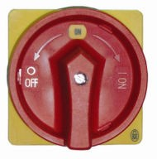

Picture 4-3：Main Power Switch

START button and STOP button:
These two buttons control the startup and stop of the machine. Emergency stop:
When an accident happens, this button can do a favor.

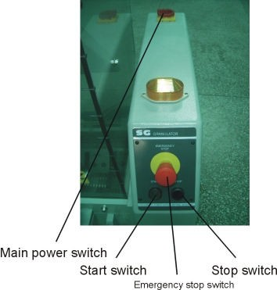

Picture 4-4：Button

CAUTION!
If there are ungrinded crew materials in the feed box or cutting chamber, the granulator shall NOT be stopped, otherwise the crew materials will blockade the rotor and the motor will be overloaded next time you start the machine up.
4.6 Motor Reversed Protective Function

When there are hard material appear in the feed box and cutting chamber or for other reason the cutting blades can not cut, this unit will enable blade shaft reverse rotating with alarm, It resumes normal operation automatically after 3 seconds later, so to keep granulating material. The alarm die out after blade shaft rotates normally. If the motor reverse function be started over 3-4 times or more, the motor would be stopped. At this time you can press down the STOP button to cut off the power, and then restart it by press the START button.

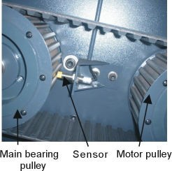

Picture 4-5：Motor Reversed Protective Function
If the rotor has been seized during operation, its working mode is:
rotor is seized up, auto stop for 1 second→reverse rotate for 3 second→stop for
1 second→normal rotate
A. 1) Normal→working
2) Seized up→stop for 1 second→reverse rotate for 3 second→stop for 1 second→normal rotate
B. 1) Normal→working
2) Seized up→stop for 1 second→reverse rotate for 3 second→stop for 1 second→normal rotate
C. 1) normal→working
2) seized up→machine stops

When mounting the sensor, please ensure that the space between sensor and main bearing pulley should be 2~4mm.

5. Trouble Shooting

5.1 Granulator Doesn't Run

1) Check if the emergency stop has not been reset. If not, rotate the Button anti-clockwise to reset it.
2) Check if the feed box is completely closed. If not, the machine could not be started. Then, check the lockup clip after opening the door.
3) Check the motor's overload protector. The overload protector in the electrical control box will work if the motor overloads. Under that situation, A) (the green pole) will sprout. Press the Reset button (B) to reset it. Before startup again, check whether there is any powder in the granulator.
4) Check the space between blades A stop will happen or the motor overload protector will work if the blade is very blunt or the space between blades is not correct. More details about checking, replacing and readjusting the blades to see chapter 3.3.

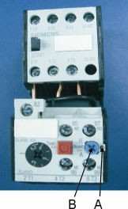

5.2 Stop Due to Other Reasons
Connection failure or looseness of safety switch can also result in operation failure.

Note!
Do not disconnect to safety switch or control switch.

6. Maintenance and Repair

6.1 Repair

All the repair must be done by professionals to avoid damage to machine and harm to human body.

6.1.1 Replace the Blades

CAUTION!
Warning: Self-rotation exists due to non-balanced forces or unstable barycenter.
Wear gloves to avoid being cut and be careful of the sharp blades!
When replacing and maintaining the blades, please refer to chapter 5.5, and comply with the installation request of fixed blade and movable blade
to assemble it. Smear the screw with threading fixative agent (it's recommended to use blue LOCTITE 243) to prevent screw from loosening.

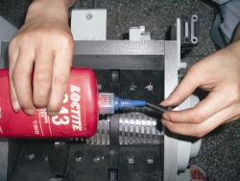

Picture 6-1：Replace the Blades
CAUTION!
To decrease the possibility of harm to other people, the replacement action must be conducted by oneself.
To avoid self- rotation, block the rotating blades with a thick wood block.

Be careful with the sharp blades.

Each time to replace the blade, the screw and insulation ring must be replaced also.
1) Remove the Fixed Blades

Caution!
To avoid self rotation, block the rotating blade with a thick wood block.
1. Remove the screws.
2. Remove the fixed blades.
3. Clean the installation surface of the blades.

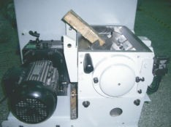

Picture 6-2：Remove the Fixed Blades
2) Remove the Rotating Blades

1. Open the cutting chamber and take out the blade rest.
2. Loosen and remove the hexagon socket cap screw.
3. Clean the whole rotating blades and cutting chamber.

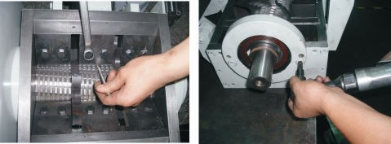

Picture 6-3：Remove the Rotating Blades
Caution!
Press the pressing block and blade when you remove the last screw so to avoid personal injuries.
3) Install the blades

Clean carefully the fixed blades and rotating blades and then install them.

CAUTION!
Each time to replace the blade, the screw and insulation ring must be replaced also. Install the rotating blades, then the fixed blades, finally the front fixed blades. More details about replacing or maintaining the blades to see chapter 3.5.
6.2 Transmission

6.2.1 Daily Maintenance of Synchronous Belts

1) Check the synchronous belts
Check synchronous belts' tensility after a full-load operation for 20-30 hours. And then check its abrasion condition monthly.
2) Check synchronous belts' tensility every 6 months.
Remove the upper panel in the back end of the granulator.
Rotate the synchronous belts for several circles to see if there is any damage.

CAUTION!
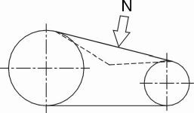Pinch risk! Do not place your hands between wheels and the belts. Check belt tension, if it is necessary, check the belt's tensility via enforce extra force and measure its excursion. Apply this strength to the middle of the belt, the extension of the belt should be no longer than 8mm. (This strength is decided by motor power and frequency as shown in the table below.

Picture 6-4：Transmission
Table 6-1：Transmission

Motor power | 0.75kW | 1.5kW | 2.2kW
New belt | 19N | 25N | 27N
Old belt | 15N | 19N | 21N

6.2.2 Adjustments of Synchronous Belts

1. Take down the side plate on the control box that is located on the right side of the machine.
2. Take out the storage box; loose the position adjusting screws of the motor.

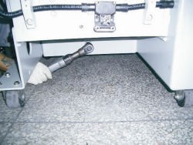

Picture 6-5：Adjustments of Synchronous Belts 1
3) The tension of the belt could be altered by adjusting the distance between motor and driving wheel. Tighten the screws after you finished the adjustment.

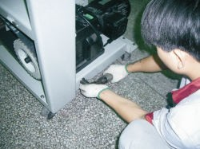

Picture 6-6：Adjustments of Synchronous Belts 2
4. Lockup the screw shows.
5. Recheck the belts' tensility after a full-load operation for 20-30 hours.
6.3 Check and Maintenance of Gear Motor

Check lubricating oil for every six monthes or after 3000 hours in operation

1) Check oil level:

a) Cut power off so to avoid electric shock and wait till the gear motor get cooled.
b) Remove oil level plug to check if the oil has been filled up full. c) Install oil level plug.

2) Check the lubricating oil:

a) Cut power off so to avoid electric shock and wait till the gear motor get

cooled.
b) Open the Oil drainage plug to get oil sample.
c) Check viscosity index of the lubricating oil. If it is evidently turbid, please replace it as soon as possible.
d) Check the lubricating oil level and install oil level plug.

3) Lubricating oil replacement:

Increased viscosity of the lubricating oil will make it harder to discharge the oil, so better replace it when the gear motor is in its operational temp.

a) Cut power off so to avoid electric shock and wait till the gear motor get cooled and there is no potential burning danger！
b) Lay an oil pan under the oil drainage plug.
c) Open the oil level plug、air valve and oil drainage plug. d) Drain all the lubricating oil out.
e) Install oil drainage plug.
f) Fill in new lubricating oil in same brand. g) Tight up the oil level plug and air valve.

4) Brand of lubricating oils (ambient temperature :-10℃~40℃):

Mobil: Mobilgear 630
Shell: Shell Omala 220
Aral: Aral Degol BG 220
BP: BP Energol GR-XP 220
Texaco: Meropa 220
6.4 Maintenance
When carrying out maintenance, ensure that there is no material left in the granulator.

CAUTION
All stuff concerning repair must be conducted by professionals to avoid damage or harm to human body.

6.4.1 Daily Check

1) There is rubber shutter in the feed box. If the rubber shutter is damaged, replace it immediately. Otherwise the fragment of the shutter will damage the blades in the cutting chamber.
2) Check whether the Emergency Stop works properly. Start the machine and then stop it via Emergency Stop. Rotate the button anti-clockwise to reset the Emergency Stop.
3) Check the main power switch, start/stop button.
4) Check the reversed rotating function.
5) Check star screw, safety screw is part of granulator' safety system , its length is pre-designed, when the screw is loosen, the granulator will stop working so to rotect the machine. The thread length of the safety screw is 60mm, damaged screw needs to be replaced by a new one.

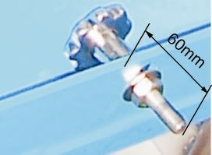

6.4.2 Weekly Check
Picture 6-7：Star Screw

1) Check the power wire to see whether there is any damage. If so, replace it immediately.
2) Check the safety switch.
3) Check the connection of electrical components.

6.4.3 Monthly Check

1) Check if the belt has any damage.
2) Check the belt's tensility for every 6 monthes, refer to chapter 6.2 for details.
3) Check the blades to see if they are loose or wear.

6.5 Cleaning

CAUTION: The blade may do harm to human body when opening the feed box!
1) Check whether the feed box is emptied before stopping the machine.
2) Clean the exterior surface of the feed box.
3) Turn off the main power switch.
4) Clean the shutter of the feed box with a dust separator.
5) Clean both surfaces of the cutting chamber. Open the upper cutting chamber and to clean the remain material by using revolvingrod (fig to turn the blade shaft.
6) Unscrew the star knob to open the feed box backwardly.
7) Clean the interior surface of the feed box.
8) Clean the screen frame and the screen.
9) Uninstall the storage box and clean it.
10) Clean the belt pulleys with bright dust-precipitator.

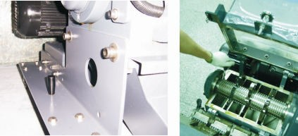

Picture 6-8：Cleaning

Do step 5 for every time of machine cleaning and also it at least has to be done for one time after 300 hours in operation.

6.6 Maintenance Schedule

6.6.1 About the Machine

Model SN Manufacture date

Voltage Ф V Frequency Hz Power
kW

6.6.2 Check after Installation

Check if the lockup screws of the blades are locked firmly. Check if the star knob is firmly tightened.
Check the rotating balance of the belt pulley.
Electrical Installation

Voltage: V Hz

Specs of the fuse: 1 Phase A 3 Phase A Check the phase sequence of the power

6.6.3 Daily Check

/ /

Check main power switch Check emergency stop switch Check start / stop button
Check material keeping back plate (strips)

/ /

Check main power switch Check emergency stop switch Check start / stop button
Check material keeping back plate (strips)

/ /

Check main power switch Check emergency stop switch Check start / stop button
Check material keeping back plate (strips)

/ /

Check main power switch Check emergency stop switch Check start / stop button
Check material keeping back plate (strips)

/ /

Check main power switch Check emergency stop switch Check start / stop button
Check material keeping back plate (strips)

/ /

Check main power switch Check emergency stop switch Check start / stop button
Check material keeping back plate (strips)

Check if there is any damaged cables
Check if there is loose electrical connections

/ /

Check if there is any damaged cables
Check if there is loose electrical connections

/ /

Check if there is any damaged cables
Check if there is loose electrical connections

/ /

Check if there is any damaged cables
Check if there is loose electrical connections

/ /

Check if there is any damaged cables
Check if there is loose electrical connections

/ /

Check if there is any damaged cables
Check if there is loose electrical connections

/ /

Check if there is any damaged cables
Check if there is loose electrical connections

/ /

Check if there is any damaged cables
Check if there is loose electrical connections

/ /

Check if there is any damaged cables
Check if there is loose electrical connections

Check the status of the belt
Check motor reversed running function
Check loading motor's time delay function
Check the overload protection function of the motor

/ /

Check the status of the belt
Check motor reversed running function
Check loading motor's time delay function
Check the overload protection function of the motor

/ /

Check the status of the belt
Check motor reversed running function
Check loading motor's time delay function
Check the overload protection function of the motor

/ /

Check the status of the belt
Check motor reversed running function
Check loading motor's time delay function
Check the overload protection function of the motor

/ /

Check the status of the belt
Check motor reversed running function
Check loading motor's time delay function
Check the overload protection function of the motor

/ /

Check the status of the belt
Check motor reversed running function
Check loading motor's time delay function
Check the overload protection function of the motor

Check belt tension
Check the bearings, motor and feed box shaft lubrication
Check the belt pulley
Valuation of machine performance

/ /

Check belt tension
Check the bearings, motor and feed box shaft lubrication
Check the belt pulley
Valuation of machine performance

/ /

Check belt tension
Check the bearings, motor and feed box shaft lubrication
Check the belt pulley
Valuation of machine performance

/ /

Check belt tension
Check the bearings, motor and feed box shaft lubrication
Check the belt pulley
Valuation of machine performance

/ /

Check belt tension
Check the bearings, motor and feed box shaft lubrication
Check the belt pulley
Valuation of machine performance

/ /

Check belt tension
Check the bearings, motor and feed box shaft lubrication
Check the belt pulley

